ALT Search Review
Rachel Volentine
https://altsearch.dataone.org/
SEARCH PAGE
- Issue: There are no links or breadcrumbs on the site. When the user opens the metadata, for instance, there is no way to get back to the search results except to use the browser’s back arrow. Additionally, sometimes the back arrow takes the users to a new search page rather than their search results. Recommend that you provide breadcrumbs, back buttons, and exit buttons as needed.

- Issue: The map on background did not always load properly.
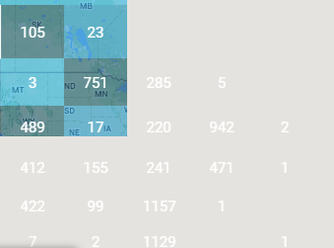

- Issue: The map loads with the Pacific Ocean in the center. As a result most of the land is hidden by the datasets page. Is there a way to load the map so that more land mass is shown?

- Issue: The spatial search (with the boxes on the map) did not always work correctly. For instance, I selected a square that said “2” and I got 25 results.

- Issue: Once you selected a spatial square and cleared the results you no longer had the option of selecting a different spatial square.
Before selecting square: After selecting and clearing results:
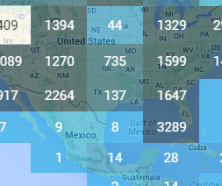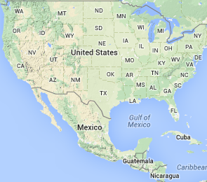

- Issue: It is not clear what the icons do. Recommend that you provide a hover-over that says what the icon does (e.g., abstract, metadata).

- Issue: The balloon icon and folder icon seem to take the user to the same place. The balloon icon is associated with geography/maps but it takes the user to a metadata page.

- Issue: It is unclear why certain datasets have the balloon icon highlighted.

- Issue: There are some “?” icons that do not do anything when the user hovers over it.
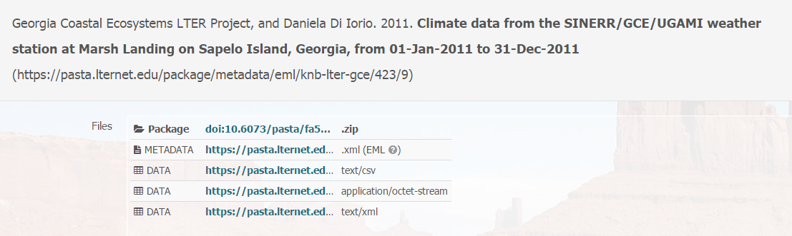
- Issue: Many users will not be familiar with filtering by data attribute or by Taxon. Recommend providing information on how to use those filters, either as a “?” icon or hover-over. Additionally, what does the grid icon represent next to data attribute? That may not be the best icon.

- Issue: The black bar on the bottom of the page is vague. What is its purpose? The DataONE logo would be better placed at the top of the page.

- Issue: Is there a reason why there is no sort by relevance in the search results?

- Issue: The top menu is misleading. “About” takes the user to credits. The DataONE logo takes the user to a new search page. Datasearch also takes the user to a new search page, and DataSummary takes the user to what is traditionally information found on the “about” page.

- Recommend changing “about” to “credits”, datasummary to “about”, and datasearch to “home” or “new search”, and get rid of “DataONE” as a link to a new search page, and instead use the DataONE logo as a link to the website (what is currently the black bar).

- Issue: If the browser window is small the information gets hard to read. Recommend decreasing the size of font and size of the items in the search page as the window decreases. For example, if someone is using the search on a small laptop they may only be able to see 1-2 search results per page.
