Usability and Assessment Working Group
Spring 2015 Meeting
University of Tennessee, Scripps Lab
28-30 April 2015

Heuristic Evaluation of search.test.dataone.org

Participants: Mike Frame, Rachel Volentine, Rachel Hu, Pedro Correa, Rob Olendorf, and Lisa Zolly

Summary

Originally we planned on designing a usability test for June, but upon examination we determined there a number of basic usability issues that needed be addressed before usability testing. We suggest addressing our comments and suggestions, and plan on the next usability test of the new search UI to take place in July at the DataONE User Group meeting.

The DUG testing will be designed around general navigation with the search tool, map navigation, using various filters, metadata record display, and include obtaining a particular dataset that includes provenance.

At the UA WG meeting, six members evaluated the search.test.dataone.org search page. We noticed major discrepancies between how the search appeared on each of our screens depending on browser and OS. We recommend doing further testing of the search functions on different browsers and operating systems.

There were also major issues with loading the map. The search page had to be constantly refreshed in order to get a working map. Additionally, the search page also had to be refreshed to start a new search. Clearing all filters did not reset the search results.

We had some general questions about how the filters worked. What is the filter preference and logic (e.g., AND vs. OR; limiting or iterative filters)? The identifier filter seems too varied across DataONE and does not seem to add value. We recommend deleting that filter. The taxon filter is not currently working.

Many of the barriers involved in the usability of this search prototype seems to be based on a lack of understanding and consistent application of requirements or understanding of the parameters of the data underneath the search. What is the ultimate goal of the search tool (e.g. replace ONEMercury? Just for provenance?)
- Adopt requirements or use case based design and development process where someone on the team looks at metadata and analyzes common denominator fields that can be displayed effectively in the available functionality.
  - If metadata does not support functionality consider removing functionality, labeling anomalies clearly if something is not available or cleaning data (if possible). Recommend UX person to conduct this work in collaboration with project manager, metadata/semantics/provenance specialist, and/or development team. Incorporate understanding of data limitations.
  - Additionally incorporating UX into the early conception phase of tools will help eliminate UX issues presenting themselves later in the process.
- Adopting a bit more definition and reconciliation process will produce a more viable product for testing purposes and save developer time and frustration in the long-term.

The issues and questions detailed below.

General Questions

- What is the product name? Will it have a “ONE”?
- How does the semantics and provenance manifest itself into the UI? It was unclear from our exploration.
- What is the filter preference and logic—“AND” vs. “OR”—limiting filters—iterative filters?
- Are the boxes in the left bar acting like facets or like search boxes?
- What are you going to do about geospatial data issues—i.e., negative sign for China?
- Taxon: Can ITIS API be used to simultaneously search (AND together) synonymous taxonomic names - preferred and non-preferred synonyms - for end users? ITIS JSON service: http://www.itis.gov/web_service.html . For instance, older metadata records from older datasets will use names that are now considered non-preferred, because the metadata and data are not updated to reflect the newer taxonomy. How can a user interested in Wood frogs get both Rana sylvatica (from older datasets) and Lithobates sylvaticus (from newer datasets), without having to know to execute 2 searches?
- What is the source for Taxon drop-downs?

General Observations and Issues

Issue: There was a visual inconsistency across browsers and OS. E.G., bottom bar was very wide and scroll bars were invisible on a Mac Chrome, no auto-complete list available in filter boxes on PC Firefox browser.

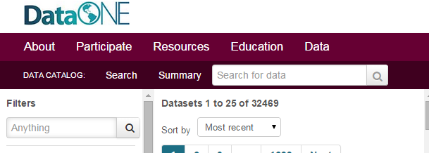

Issue: Top search bar (“Search for data”) is confusing in terms of how it functions with the filter options. There is a visual disconnect between the two search options. Recommend aligning all search fields and filter options.

Issue: The Data Catalog bar (with search, summary, and search box) is confusing. The location of the “Search” and the “Summary” page links are oddly placed. We were not sure how Summary page fit in with the search. Moving the search bar to the left and moving the summary link to the right side may help distinguish the different functions.

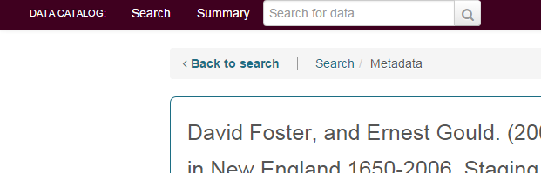

Issue: On the Metadata page the “Back to Search” bar moves locations (See Above).

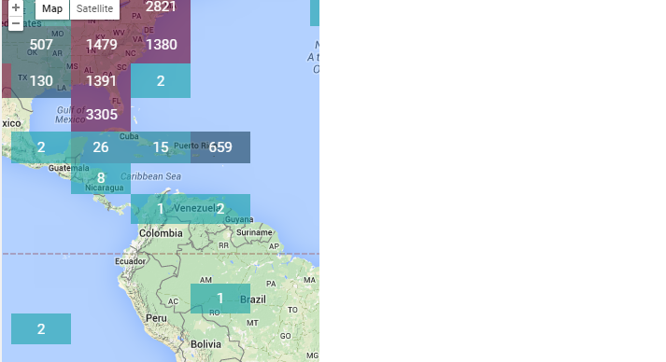

Issue: There were a lot of issues with loading the map. On PC Chrome the map always loaded like the above picture. There were various other issues with the map.

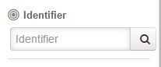
Issue: Identifier field does not seem necessary. Seems too varied across DataONE and does not seem to add any value.

Issue: All users will not be familiar with Member Nodes. Recommend added a “?” icon to provide description of the term.

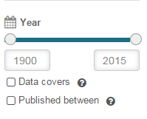
Issue: If DataONE includes data from 1800, why does the slider default start at 1900?

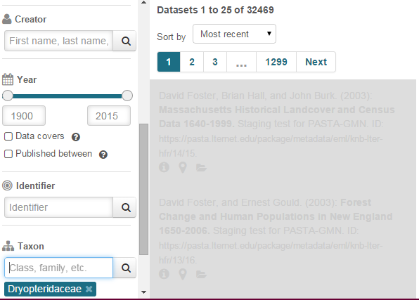

Issue: Taxon filter does not work. Only receive a gray search field.

Issue: Recommend replacing gray-shading with a load-indicator icon (e.g., spinning wheel). Spinning wheel is a better indicator of impending action.

Issue: Some members were confused by the icons. In particular, members struggled to understand what the data file icon was (i.e., folder). Usability testing will help determine where there are issues with the icons and how to improve them.

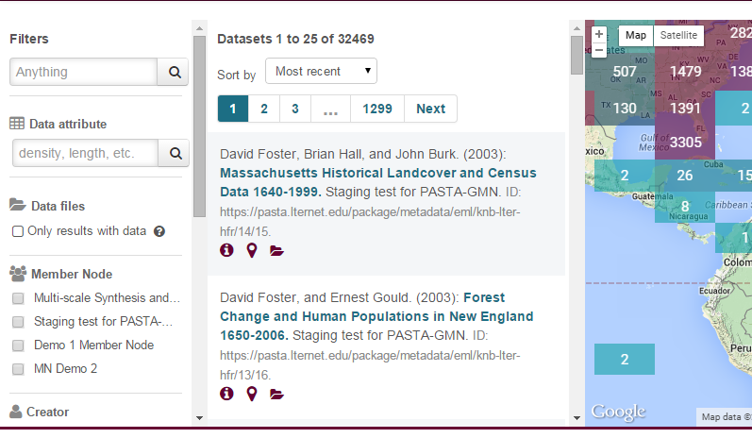
Issue: Recommend resizable columns by dragging.

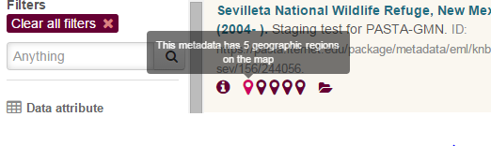
Issue: There does not seem to be much value-added to the roll-over of geographic regions. Recommend adding more individual description to the roll-over. Is there a way to have each roll-over say the specific geographic region?

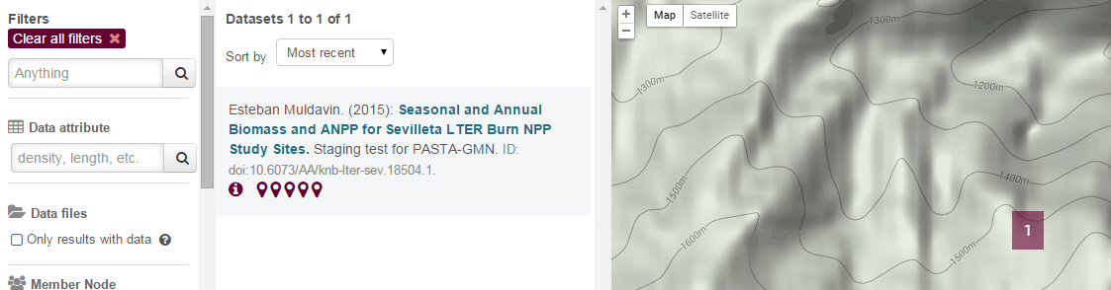

Issue: When you drill down on the map there is no way to go back up in the hierarchy. Recommend including a “Back” button or including each location filter as a separate filter word.

Issue: Clearing filters did not reset the dataset results. The page had to be reloaded in order to start a new search query. In the above example the filters were cleared but the datasets still show only 66 results.

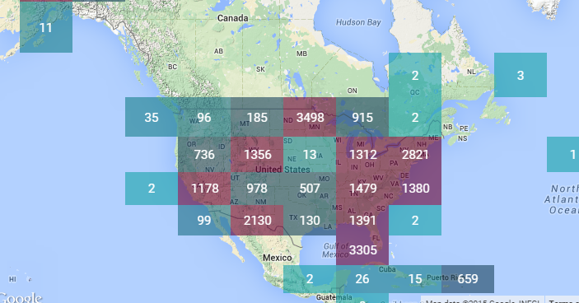

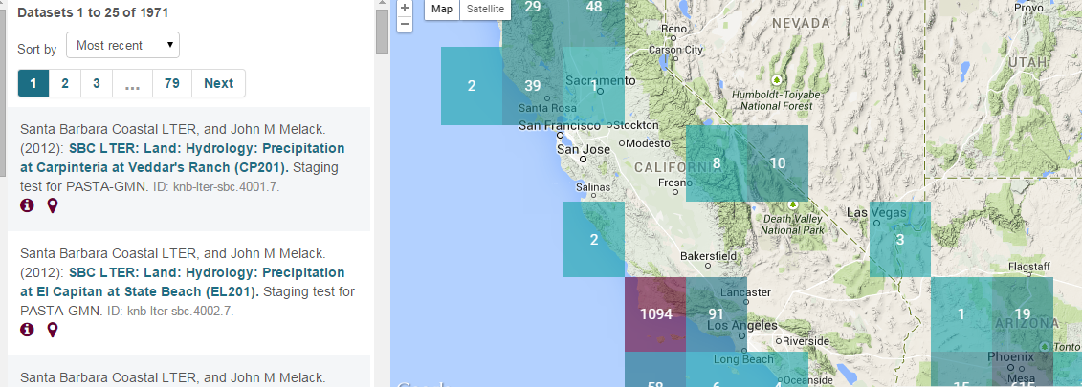

Issue: Clicking on a geospatial square on the map did not result in that number of datasets appearing in search results. The number of results is dependent on what is shown on the map rather than what is shown in the square. For example, I clicked on the “1178” square but have 1971 results.

