Cross browser testing

Issues that occur across browsers and OS

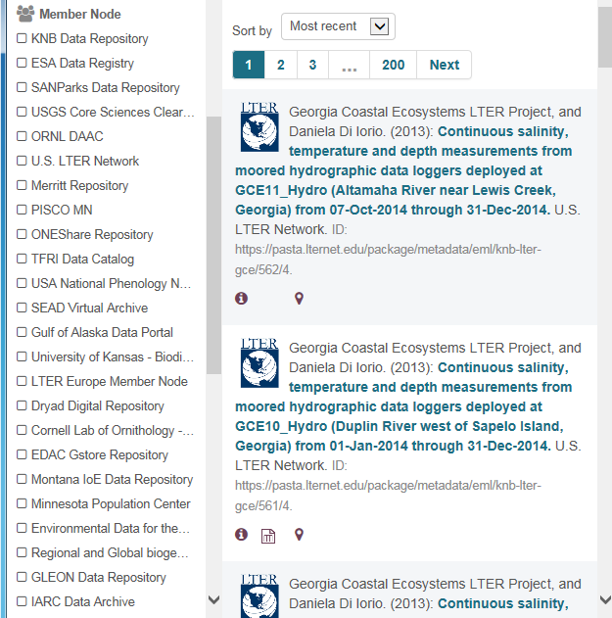

**Suggestion:** Doesn’t pertain to browser testing but it would be nice if there was a way to re-collapse the MN list after you select “show 23 more MNs”

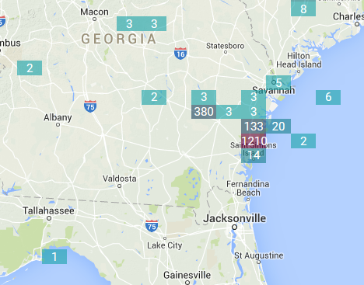 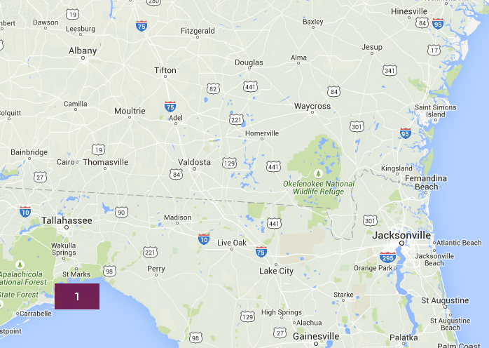

**Issue:** One level of zoom looks like left picture but when you try to zoom in further on the results around Fernandina Beach you get the second screenshot. Where’d they all go? I found a similar issue with other areas of the map where zooming would cause some results to disappear.

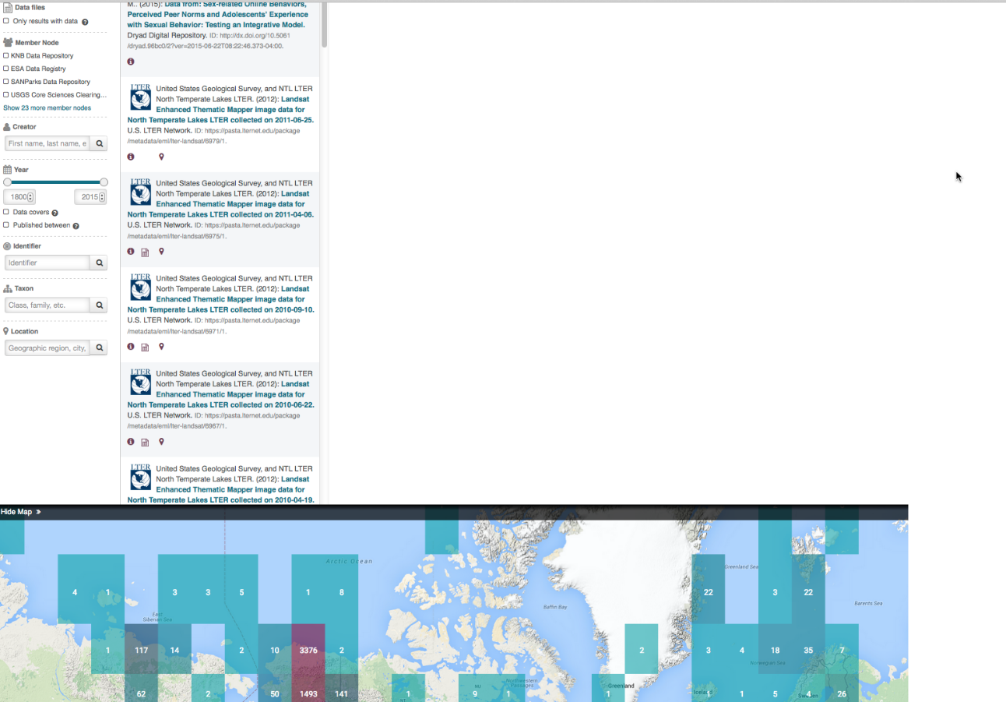

**Issue**: When you use your browser to zoom in (less than 100%) the map moves to the bottom of the page.

**ISSUE:** the map does not allow you to drag it. Every time I try to drag the map from the US to China or in another direction it goes back to the US once I let go of the mouse.