Chrome and Windows 7
I found the “Year” filter didn’t seem to narrow down the Datasets:
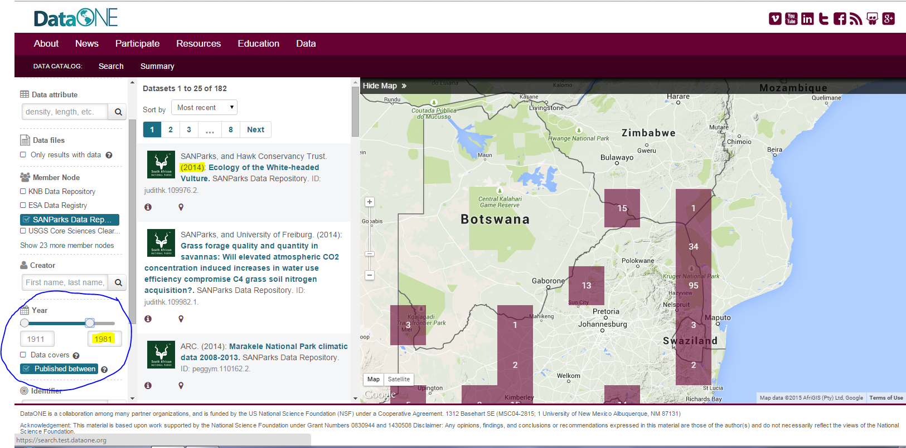
Despite adjusting the parameters, I would still see results outside the time frame that I adjusted. Also, sometimes the Year filter would reload itself to display an expanded time frame different from what I intended, often expanding to the limit of 2015.

Firefox 38 and Windows 7
- On Summary view, I couldn’t tell what the x-axis on the Files Uploaded chart was representing. Was this a Summary of Uploaded Holdings only in that moment or would it show the uploads over a period of time?
  - Was also wondering if the file formats listed were mutually exclusive? For example, are the metadata files always attached to a data file or are they only for those records without an uploaded dataset?
14 datasets show in results view.
15 datasets show in map view.

- On Map view, was expecting that as I zoomed in on a geographical area that the number of datasets shown in that area would be shown in dataset search results. And for the most part this was true except for a few datasets that were visible but in the periphery compared with more centrally located datasets.

- The dataset view has this odd “files in this dataset” box that is causing a horizontal scroll bar to appear on the Firefox browser. The “download” button (in this box) is off the initial screen view. This box should be more clearly incorporated into the main body of the dataset page.
- Also, on this particular dataset page I didn’t realize until I tried to click download on the Files in this dataset box that this was a metadata only page. The downloadable file was an XML metadata file not the actual dataset files. This was confusing. Ideally, users should be able to differentiate on the search results page as well as the record level page if something if a metadata only record (even if the downloadable record is metadata) or if it actually has datasets available for true download. (Here is the record URL for context…https://search.test.dataone.org/#view/doi_10.5066_F78W3B9C) On the search results page, it does indicate where you have downloadable files but sometimes those files are metadata files and not actual data files so that’s unexpected.
- Also, I was using my browser’s back button to go back to the search results and compare the citation on the results page vs what I was seeing on the records page. After awhile I was unable to use the back button to retrieve the last search results page. It kept saying there were 0 results. There was no reset or clear search functionality to allow me to start my search over again. I tried to click on the search link but nothing worked to send me back to a default view so I could start my search refinement over again. I had to re-load the entire URL to get back to the default view. Belatedly, I noticed a “clear filters box in the filters section of the page but that was difficult for me to understand that this was referring to the clearing or changing of the search results view as well as the maps view. It would be nice to have some kind of overall clear search functionality or when you clicked on “Search” next to “Data Catalog” that it would reset the search.
- On the search results page itself, I found it odd that the search box was on top of the filters. I was expecting it to be on top of the results set. To me, filtering indicates the functionality beneath the keyword search box. (Example of layout of filters, vs search box, vs search results-- http://dp.la/search?q=science&utf8=%E2%9C%93) DPLA also has a nice map filter view.
- On the filter view, the “Year filter” has beginning and end indicators on the year timeline filter mechanism. At first I could only see one indicator so was surprised and a little uncertain when I saw the other indicator pop up out of the blue. Also, the years within the range seemed different from the expanded view (without the map view) vs the reduced view (with the map open)

