DataONE User Profile Login UX Test Results
Rachel Volentine, UXL Manager
November 11, 2015

Methodology
The User-Experience Lab manager created an online survey with Qualtrics. The UX Lab Manager sent 16 scientists an e-mail with a link to the survey, and the Member Node Coordinator invited 9 members of the Member Node Community to participate. The survey was open from November 9-11 2015. Survey results were anonymous. Fourteen respondents completed the survey.

Survey Results
Participants were shown three images of the login screen.

Image 1. Horizontal Layout
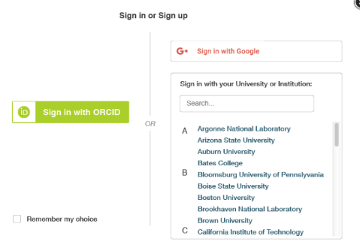

Image 2. Vertical Layout
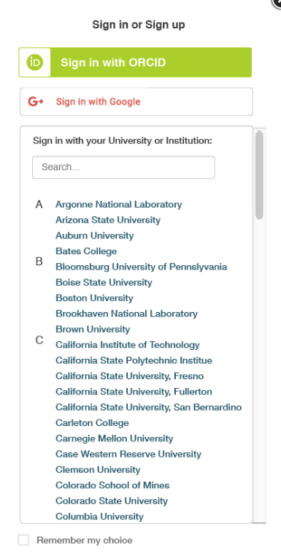

Image 3. Full Page Layout
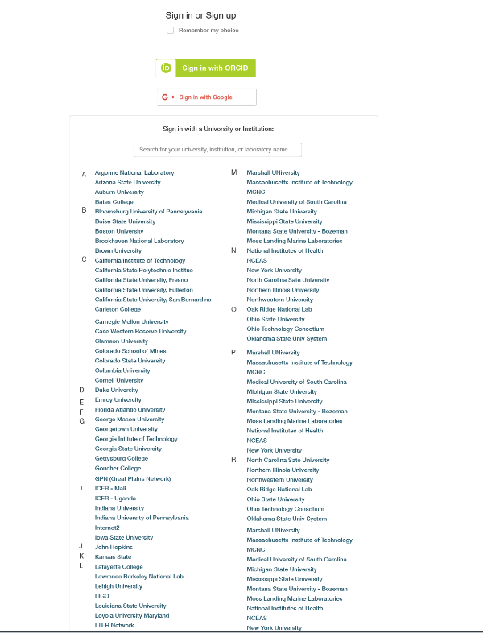

Half of the participants preferred the horizontal layout (7 out of 14), and five participants preferred the vertical layout, while only two respondents preferred the full page login screen. We asked the participants to explain why they preferred their selected layout.

Participants preferred the horizontal layout because:
- It looks clean and reminds me of other login screens
- I like the compactness of the information. I thought all of the choices were visible in a more immediate fashion.
- More similar to other websites. Encourages use of ORCID. Aesthetically balanced.
- It sets the user’s perception of a default identity provider more clearly than the vertical or full page login screens.
- It is the most compact and makes the 3 options clearest. I don’t think it is necessary to see a long list of institutions like in the other two layouts.
- Clear and tidy

Participants who preferred the vertical layout said:
- It’s consistent with other login pages. I don’t need to have my eye travel in multiple directions.
- I have had problems with ORCID, and with it on the left of the horizontal screen, I have a personal aversion to that! As I do with it on the top…(I have two ORCID profiles and cannot reconcile them). Maybe I shall feel better with time, but also the vertical view will provide better ability to sign in with a mobile phone. I think the full screen is too much information. I do have a problem with the list of universities, as they are exclusively USA, which is fine for now, but as DataONE grows and becomes more global, how will that be dealt with? Country and affiliated universities? How to do this? I t could get most unwieldy, but good to have a future plan now.
- Seems clearer what the alternatives are.
- My eyes followed it the easiest and was the quickest to understand.
- Gives equal treatment to the 3 options, but I think you might want to encourage people to use ORCID (especially young researchers) because it could stay with them their entire career. You could either state that explicitly or in the vertical layout separate the ORCID login with OR (in the sense “of if you must” from G+ and institution.

The participants who preferred the full page screen said they liked that they could see a more complete list of member organizations.

We also asked them if there is anything we can do to further improve the login. The participants suggested:

From those who preferred the horizontal layout:
- I wish it was clearer how to sign in if you do not already have an account. Maybe add a “New User/Sign up’ link that takes the user to another page that explains options or could be a pop up bubble.
- The colors were off-putting and seemed uncoordinated.
- (for horizontal layout) I would suggest moving the Google login option to the left side, under the ORCID option, and moving the Remember my choice check box to the bottom center of the screen (assuming it applies to all three options, as it seems to in the other layouts).

From those who preferred the vertical layout:
- The listing is long, an alphabetical quick link (A B C D E…) would speed things up.
- Is there a possibility of a facebook login?
- The boxes around the different alternatives seem important so people know that they have different choices.
- Would you know enough by the client IP to tell which institution the user is likely coming from and preselect that university or institution list?

Only one of the participants who preferred the full page login screen had a suggestion for further improvement. They wanted the page to remember the login method because that is unlikely to change each time.

We ended the survey by asking participants which of the login options they are most likely to use. Eight participants said Google, 3 said Orcid, and 3 said University/Institution.

Discussion

The majority of respondents preferred the horizontal layout that emphasizes ORCID; however, users are likely to use Google to login. The long list of universities and institutions can be overwhelming, especially if the list continues to grow. Shortening the list to an alphabetical quick link (A B C D E…) may help users jump to the right section.

One participant suggested the vertical layout is more mobile friendly, which is an important consideration if many users access the profile page from a tablet or phone. The long list of institutions and universities on the vertical screen seems to be what detracted from its popularity, and if the university list became an alphabetical quick link that may alleviate the issues

