DataONE Search User Profile User-Experience Test Results
Rachel Volentine, Center for Information and Communication Studies
rvolenti@utk.edu
December 10, 2015

DataONE Usability and Assessment Working Group conducted a usability study of the DataONE Search User Profile. This report discusses the findings.

METHODOLOGY

Testing was conducted December 7-10th 2015. Testing was completed through remote usability testing and through an online survey. Participants were recruited through the Member Node Forum and the DataONE Scientist Panel. An e-mail invitation was sent to both groups on December 2nd asking them to participant in a remote usability test through Webex. Only three users responded. In order to garner more user feedback, a Qualitrics online survey was created and distributed through the Member Node Forum e-mail list and to the scientist panel. Four users completed the online survey.

In the remote usability test, participants were shown five mock-ups of the DataONE Search user profile (member node profile, group profile, individual profile, blank/empty profile, and identification code page). Participants were asked for insights into the profile’s design, layout, and content, including anything they did not understand or anything they felt was missing. The images used during testing are included at the end of the report. The usability test took an average of 20 minutes.

In the online survey participants were shown the five user profile pages and asked to provide feedback, including first impressions, if there was anything they did not understand, or anything they thought was missing.

TEST RESULTS

Member Node User Profile

Overall, participants thought the layout was simple, easy to understand, and intuitive. They liked that there was a short summary of Dryad on the page, since not all users knew much (or anything) about Dryad. They would also like to be able to find additional information about the Member Node. The user profile could be linked to the Member Node Dashboard.

Participants pointed out that there is no heading or description that describes the content of the page. It is not necessarily obvious that the user is looking at the Dryad data holdings. This issue may be cleared up by how the user accesses the page, but it may be helpful to include a heading for the user profile pages.

Another issue that users pointed out was the vertical layout of the page. It is not obvious that there is any information below the fold. They only item that is shown above the fold is the dataset list. It would be helpful if there was some indication of the content below the fold. Again, this may be more obvious depending on how the user accesses the page and if there is a heading for user profiles.

Group User Profile

As with the Member Node profile, participants liked the clean layout. They thought the Download and Upload statistics were helpful. They wondered when and how often the statistics were updated. They would like to see a date so they could know currency.

It was not always clear to users what they were seeing in the group page. They were confused about if group datasets could only come from one member node or could there be multiple member node contributors. It was also unclear how the group related to the datasets since the author/owner of the dataset is not a group member. If only members of the group can see the page, there should not be any issues, but if the group profile is searchable it may be nice to include a short description/summary of the group (like with Member Nodes) to help clarify the content.

Individual User Profile

Participants liked the layout. They thought adding a picture or avatar to the individual profile could be helpful, mimicking other social media/online pages.

They liked the idea of being able to share e-mail address or contact information (including associations); however, they pointed out that many scientists change jobs frequently and the contact information could be outdated. Contact information could be tied to Orcid or other sign-in information.

All participants thought the user profile should be public. They thought a public profile was a part of sharing data and having a profile could help improve visibility while helping users determine the quality of a data package. If the data owner/lead author is not the uploader, there could be a mechanism in place that sends a notification to the author when a data set is submitted.

Participants liked the file format and time period statistics. They liked the idea of being able to click on one of those charts to filter the author’s data sets.

Empty User Profile

Participants thought the grayed out images was unnecessary. They would keep the short description (“Lauren Walker hasn’t uploaded anything yet.”) and remove everything else.

Identification Code Page

Participants thought the page was easy to understand. They would like to see documentation about how to use the code/token. If there were other methods beside R and MatLab to use the code/token, they would like to be more obvious on the page.

While the term “identification code” was understandable, participants liked the term “token”. Six of the seven participants preferred “authentication token.”

User Profile Images

Member Node User Profile
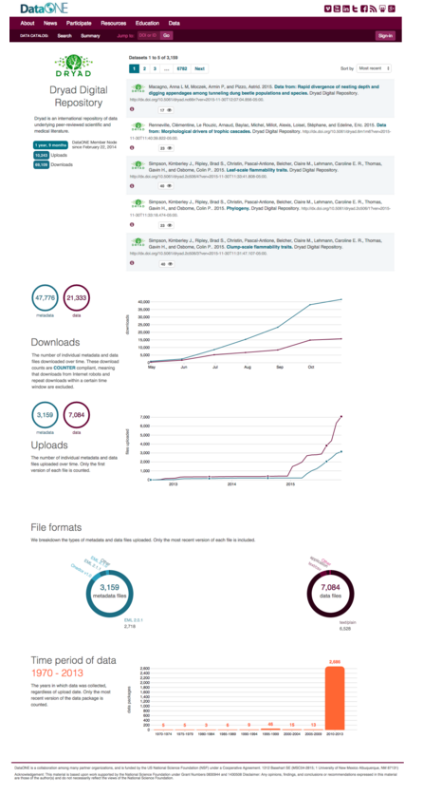

Group User Profile

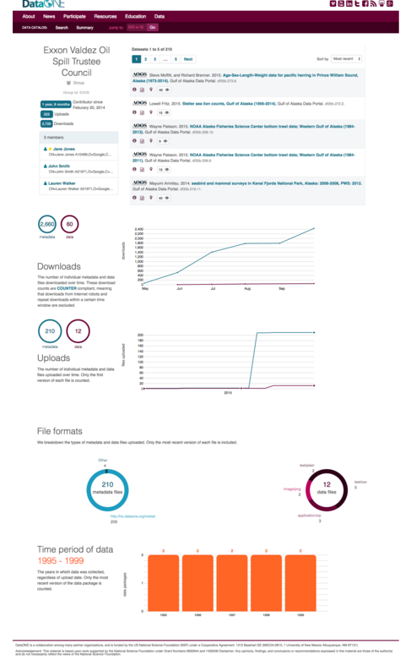

Individual User Profile
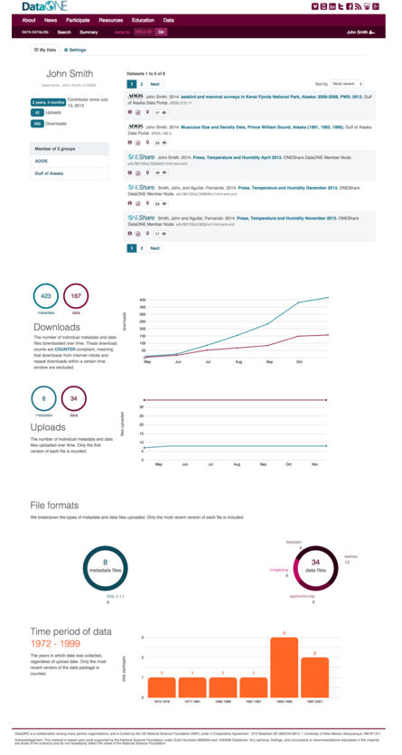
Empty User Profile

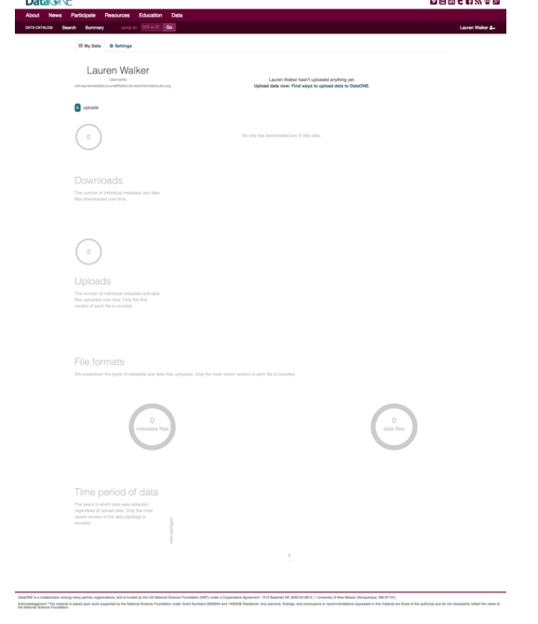

Identification Code

