Metacat Administrator's Guide 1.9.1
March 18, 2009

1 Introduction 2
1.1 What’s in this Guide 4
1.2 Metacat Features 4
2 Downloading and Installing Metacat 5
2.1 System Requirements 5
2.2 Installing on Linux 5
2.2.1 Downloading Metacat 5
2.2.1.1 Download the Metacat Installer 6
2.2.1.2 Download Metacat Source Code (Needed for Registry?) 6
2.2.1.3 Check Out Metacat Source Code from SVN 7
2.2.2 Installing and Configuring Required Software 8
2.2.2.1 Java 5.0 8
2.2.2.2 Apache Jakarta-Tomcat 8
2.2.2.3 Apache Web Server (Highly Recommended) 9
2.2.2.4 PostgreSQL Database or Oracle 8i 12
2.2.2.5 Apache Jakarta-Ant 14
2.2.3 Installing Metacat 14
2.2.3.1 New Install 14
2.2.3.2 Upgrade Metacat 15
2.2.3.3 Source Install 16
2.2.4 Optional Installation Options 17
2.2.4.1 Web-based Registry 17
2.2.4.2 LSID Server 21
2.2.5 Troubleshooting 22
2.3 Installing on Windows 22
2.3.1 Downloading Metacat 22
2.3.2 Installing Required Software 23
2.3.2.1 Java 5.0 23
2.3.2.2 Tomcat 23
2.3.2.3 PostgreSQL Database 24
2.3.3 Installing Metacat 25
2.3.3.1 New Install 25
2.3.3.2 Upgrade 25
3 Configuring Metacat 27
3.1 Initial Configurations 27
3.1.1 Back-up Configuration 27
3.1.2 Authentication Configuration 28
3.1.3 Changing Authentication Configuration without Authentication 29
3.2 Logging in to the Metacat 30
3.3 Required Configurations 30
3.3.1 Global Properties (server, ports, etc) 32
3.3.2 Authentication Configuration 34
3.3.3 Skins Configuration (look & feel) 34
3.3.4 Database Configuration 36
3.3.4.1 New Installation 36
3.3.4.2 Upgrade 37
3.3.5 Geoserver Password Configuration (Highly Recommended) 38
3.4 Optional Configuration 40
3.4.1 PROPERTIES NOT IN CONFIGURATION UTILITY?? 40
3.4.2 Geoserver Configuration 40
3.4.3 Harvester Configuration 40
3.4.4 SAX Parsing ??— (Not sure where this goes/how used yet) 40
3.4.5 Set a default style-set (?) Qformat (html, xml, style-set) (Or is this in global now/mandatory?) 40
3.4.6 Replication 40
4 Accessing and Submitting Metadata and Data 41
4.1 A Brief Note about How Information is Stored 41
4.2 Using the Registry 41
4.3 Using HTML Forms (the HTTP Interface) 42
4.3.1 Supported Actions 43
4.3.2 Inserting, Updating, and Deleting XML and Data Documents 48
4.3.3 Searching Metacat 50
4.3.4 Paged Query Return 53
4.3.5 Reading Data and MetaData 54
4.4 Using Morpho 55
4.5 Creating Your Own Client 55
5 Metacat's Geoserver 58
5.1 Installing and Configuring 59
5.1.1 Adding a Map to a Web Page or Skin 59
5.1.2 Configure the Size and Initial Extent of the Map 60
5.1.3 Configure the Layout of the HTML Mapping Interface 60
5.1.4 Change the Lat/Long Display to Degree-Minutes-Seconds 61
5.1.5 Configure the "Select Location" Drop-down Menu 61
5.1.6 Configure the styling and classification of the data 62
5.1.7 Adding Other Spatial Datasets to the Web Map 62
5.2 Spatial Query 63
5.3 HTML Mapping Client 64
6 Replication 64
7 Harvester and Harvest List Editor 64
8 Logging 65
9 Creating a Site Map 65
10 Appendix: API (maybe here) 65
11 NOT SURE WHERE LDAP SERVER SHOULD GO 65

Introduction

Developed for ecologists, Metacat is a repository for metadata (data about data), which help scientists find, understand and effectively use the data sets they manage or that have been created by others. Thousands of data sets are currently documented in a standardized way and stored in Metacat systems, providing the scientific community with a broad range of ecological data that--because the data are well and consistently described--can be easily compared, merged, or used in other ways.

Not only is the Metacat repository a secure place to store metadata and data (the database is replicated so that every record is stored on multiple machines and no data is ever lost to technical failures), it provides a user-friendly interface for information entry and retrieval. Scientists can search the repository via the Web using a customizable search form. Searches return results based on user-specified criteria, such as desired geographic coverage, taxonomic coverage, and/or keywords that appear in places such as the data set's title or owner's name. Users need only click a linked search result to open the corresponding data-set documentation in a browser window and discover whom to contact to obtain the data themselves (or how to immediately download the data via the Web).

Metacat's user-friendly Registry application allows data providers to enter data-set documentation into Metacat using a Web form. When the form is submitted, Metacat compiles the provided documentation into the required format and saves it. Information providers need never work directly with the XML format in which the data are stored or with the database records themselves. In addition, the Metacat application can easily be extended to provide a customized data-entry interface that suits the particular requirements of each project. Metacat users can also choose to enter metadata using the Morpho application, which provides data-entry wizards that guide information providers through the process of documenting each data set.

The metadata stored in Metacat includes all of the information you and others need to understand what the described data are how to use them: a descriptive data set title; an abstract; the temporal, spatial, and taxonomic coverage of the data; the data collection methods; distribution information; and contact information. Each information provider decides who has access to this information (the public, or just specified users), and whether or not to upload the data set itself with the data documentation. Information providers can also edit the metadata or delete it from the repository, again using Metacat's straightforward Web interface.

Metacat is a Java application that runs on Window or Linux platforms in conjunction with a database, such as Oracle 8i or PostgreSQL, and a Web server. The Metacat application automatically configures the database for the entered metadata, which is stored in an XML format using Ecological Metadata Language (EML) or another ecological metadata standard. For more information about Metacat or for examples of projects currently using Metacat, please see http://knb.ecoinformatics.org.

What’s in this Guide

The Administrator guide includes information for installing, configuring managing and extending Metacat for both Linux and Windows systems. Chapter 2 contains instructions for downloading and installing Metacat and the applications required to run the software on Linux and Microsoft platforms. Chapter 3 covers how to configure Metacat, both for new and upgraded installations. Chapter 4 details the ways in which you can customize the Metacat interface so users can access and submit information easily: using Metacat's generic web-interface (the Registry), creating your own HTML forms, and creating your own desktop client (like Morpho). Chapter 5 discusses how to work with Metacat's (optional) geoserver. Chapter 6 describes how to set up the Metacat's replication service, which permits Metacat servers to share data with each other, effectively backing up metadata and data files. Chapter 7 looks at the Metacat Harvester, a program that automates the retrieval of EML documents from one or more sites and their subsequent upload (insert or update) to Metacat. Chapter 8 discusses logging, Chapter 9 contains instructions for creating a site map, which makes individual metadata entries available via Web searches. Metacat's Java API is included as an appendix at the end of the guide.

Metacat Features

Metacat is a repository for metadata (data about data), which help scientists find, understand and effectively use the data sets they manage or that have been created by others. Specifically,

- Metacat is a Java servlet, which can run on both Windows and Linux systems
- Metadata submitted to Metacat is broken into modules, which are stored to optimize rapid information retrieval
- Metacat's Web interface facilitates the input and retrieval of data
- Metacat's optional mapping functionality enables you to query and visualize the geographic coverage of stored documents
- Metacat's replication feature ensures that all Metacat data is safely backed up
- The Metacat interface can be easily extended via customized Web forms or desktop clients
- The Metacat harvester automates the process of retrieving and storing EML documents from one or more sites
- Metacat can be customized to use Life Sciences Identifiers (LSIDs), uniquely identifying every data record
- Metacat has a built-in logging system for tracking events such as document insertions, updates, deletes, and reads
- The appearance of Metacat's web interface can be customized via skins.

Downloading and Installing Metacat

System Requirements

In addition to meeting the recommended system requirements, the server on which you wish to install Metacat must have the following software installed and running correctly:

- PostgreSQL (or another SQL92-compliant RDBMS like Oracle 8i)
- Apache Jakarta-Ant
- Apache Jakarta-Tomcat
- Apache web server (recommended*)
- Java 5.0

System requirements for running Metacat:

- a server running an SQL92-compliant database (Oracle 8i or PostgreSQL)
- at least 128MB RAM
- a Pentium III processor (or higher)
- 11 MB disk space (Note: The amount of disk space required depends on the size of your RDBMS tablespace (which should be at least 10 MB; however, Metacat itself requires only about 1 MB of free space after installation).

* In order to use the Metacat Registry (and for a more robust Web-serving environment in general), the Apache Web server should be installed with Tomcat and the two should be integrated as described on the Apache Web site.

Installing on Linux

Section 2.2 contains instructions for downloading and installing Metacat on Linux systems.

Downloading Metacat

Before installing Metacat, please ensure that all required software is installed and running correctly. To obtain a Metacat WAR file, which is needed for installation, download one of the following:

- the Metacat installer, which has a pre-built WAR file,
- the Metacat source distribution, which must be built in order to create a WAR file,
- the Metacat source code from SVN. You must build the source code in order to create a WAR file.

Instructions for all three options are discussed below. Note that downloading the installer (described in the next section) is the simplest way to get started.

Download the Metacat Installer

Downloading the Metacat Installer is the simplest way to get started with the application. To download the installer:

- Browse to the KNB Software Download Page. In the Metacat section, select the link to the "GZIP file" (the link should look like: metacat-bin-X.X.X.tar.gz, where X.X.X is the latest version of Metacat) [NOTE: THIS FILE IS NOT LINKED FROM DOWNLOAD PAGE]
- Save the file locally.
- Extract the Metacat package files by typing:
tar -xvzf metacat-bin-X.X.X.tar.gz

You should see a WAR file and several supporting files (Table 2.1). The extraction location will be referred to as the <metacat_package_dir> for the remainder of this documentation.

File | Description
knb.war | The Metacat Web archive file (WAR)
knb | The Web definition file used by Apache on ubuntu/debian Linux systems.
jk.conf | The JkMount configuration file used by Apache on ubuntu/debian Linux systems.
workers.properties | The workers definition file used by Apache on ubuntu/debian Linux systems.
tomcat5.5 | The Tomcat startup script for Tomcat 5.5 installed with apt-get on ubuntu/debian Linux systems.
authority | The optional LSID Server application WAR
Table 2.1: Files extracted from the Metacat GZip file.

Download Metacat Source Code (Needed for Registry?)

If you would like to install the Metacat Registry application?, GeoServer? or XXX, you should download and build the Metacat source code. To get the Metacat source distribution:

- Browse to the KNB Software Download Page. In the Metacat section, select the link to the Metacat Source code (it will look something like this: metacat-src-X.X.X.tar.gz, where X.X.X is the latest version of Metacat)
- Save the file locally.
- Extract the Metacat package files by typing:
tar -xvzf metacat-bin-X.X.X.tar.gz

- Rename the metacat-X.X.X directory to metacat.

Note that you do not need to create the WAR file directly because the Ant build-file has an "install" target that will build and deploy the WAR for you.

Check Out Metacat Source Code from SVN

If you wish to work with the most recent Metacat code, or you'd like to extend the Metacat code yourself, you may wish to check out the Metacat source code from SVN. You will need both Subversion (SVN) and CVS clients installed and configured on your system (see the end of this section for information about obtaining these clients). Both are needed because, although Metacat has been migrated to SVN, some of its supporting libraries (eml, utilities, and seek) have not yet been migrated.

To check out the code from SVN, go to the directory where you would like the code to live and type:

svn co https://code.ecoinformatics.org/code/metacat/tags/METACAT_<rev> metacat

Where <rev> is the version of the code you want to check out (like 1_9).

To check out the head, type:
svn co https://code.ecoinformatics.org/code/metacat/trunk metacat

You should see a list of files as they check out.

HOW TO CHECK OUT CVS FILES?? The libraries stored in the CVS repositories will be checked out when you build the souce code. [true?]

Note that you do not need to create the WAR file directly because the Ant build-file has an "install" target that will build and deploy the WAR for you.

Installing SVN and CVS Clients:

If you have not already installed Subversion and you are running Ubuntu/Debian, you can get the SVN client by typing:
sudo apt-get install subversion

Otherwise, you can get the SVN client from The Subversion homepage.

If you have not already installed CVS and you are running Ubuntu/Debian, you can get it by typing:
sudo apt-get install cvs

Otherwise, you can get it from The Ximbiot CVS homepage.

Installing and Configuring Required Software

Before you can install and run Metacat, you must ensure that a recent Java SDK, Oracle 8i (or another SQL92-compliant RDBMS like Postgres), Ant, and Tomcat are installed and running correctly. We also highly recommend that you install Apache Web server, as it provides a more robust Web-serving environment and is required by some Metacat functionality.

Java 5.0

To run Metacat, you need a recent Java SDK. The latest Metacat release (1.8.1) has been tested most extensively with J2SE 5.0, and this is the recommended version; J2SE 1.4.2 or later is required. Make sure that the JAVA_HOME environment variable is properly set and that both java and javac are on your PATH.

To install Java if you are running Ubuntu/Debian, type:

sudo apt-get install sun-java5-jdk

Click "ok" then "yes" for license agreement.

Otherwise, you can get Java from the Sun website.

Apache Jakarta-Tomcat

We recommend that you install Tomcat version 5.5 into the directory of your choice. Included with the Metacat download is a Tomcat-friendly start-up script that should be installed as well.

Note: we will refer to the Tomcat installation directory as <tomcat_home> for the remainder of the documentation.

If you are running Ubuntu/Debian, you can get Tomcat by typing:
sudo apt-get install tomcat5.5

Otherwise, you can get Tomcat from the Apache Tomcat page.

Install Tomcat 5.5 by typing:
sudo apt-get install tomcat5.5

Install the Metacat-friendly Tomcat start-up script by typing:
sudo /etc/init.d/tomcat5.5 stop
sudo mv /etc/init.d/tomcat5.5 /etc/init.d/tomcat5.5.bak
sudo cp <metacat_package_dir>/tomcat5.5 /etc/init.d/tomcat5.5
sudo chmod +x /etc/init.d/tomcat5.5

Apache Web Server (Highly Recommended)

Although you have the option of running Metacat with only the Tomcat server, we highly recommend that you run it behind the Apache Web server. Running Tomcat with the Apache server provides a more robust Web serving environment. The Apache Web server is also required if you wish to install and run the Metacat Registry. This section contains instructions for installing and configuring the Apache Web server for Metacat on an Ubuntu/Debian system. Instructions for configuring Apache running on other Linux systems are included at the end.

- Install the Apache and Mod JK packages (Mod JK is the module Apache uses to talk to Tomcat applications) by typing:
sudo apt-get install apache2 libapache2-mod-jk

If you are installing the Apache server on an Ubuntu/Debian system, and you installed Apache using apt-get as described above, the Metacat code will have helper files that can be dropped into directories to configure Apache. Depending on whether you are installing from binary distribution or source, these helper files will be in one of two locations:

- the directory in which you extracted the distribution (for binary distribution)
- <metacat_code_dir>/src/scripts (for both the source distribution and source code checked out from SVN)

We will refer to the directory with the helper scripts as <metacat_helper_dir> and the directory where Apache is installed as <apache_install_dir>.

- Set up Mod JK apache configuration by typing:
sudo cp <metacat_helper_dir>/jk.conf <apache_install_dir>/mods-available
sudo cp <metacat_helper_dir>/workers.properties <apache_install_dir>

- Disable and re-enable the Apache Mod JK module to pick up the new changes:
sudo a2dismod jk
sudo a2enmod jk

- Apache needs to know about the Metacat site. The helper file named "knb" has rules that tell Apache which traffic to route to Metacat. Set up the knb (Metacat) site by dropping the knb file into the sites-available directory and running the a2ensite to enable the site:
sudo cp <metacat_helper_dir>/knb <apache_install_dir>/sites-available
sudo a2ensite knb

- Restart Apache to bring in changes by typing:
sudo /etc/init.d/apache2 force-reload

Configuring Apache on an OS other than Ubuntu/Debian
If you are running on an O/S other than Ubuntu/Debian (e.g., Fedora Core or RedHat Linux) or if you installed the Apache source or binary, you must manually edit the Apache configuration file, where <apache_install_dir> is the directory in which Apache is installed:

<apache_install_dir>/conf/httpd.conf

- Configure the log location and level for Mod JK. If your configuration file does not already have the following section, add it and set the log location to any place you'd like:

<IfModule mod_jk.c>
JkLogFile "/var/log/tomcat/mod_jk.log"
JkLogLevel info
</IfModule>
- Configure apache to route traffic to the Metacat application. ServerName should be set to the DNS name of the Metacat server. ScriptAlias and the following Directory section should both point to the cgi-bin directory inside your Metacat installation.

<VirtualHost XXX.XXX.XXX.XXX:80>
DocumentRoot /var/www
ServerName dev.nceas.ucsb.edu
ErrorLog /var/log/httpd/error_log
CustomLog /var/log/httpd/access_log common
ScriptAlias /cgi-bin/ "/var/www/cgi-knb/"
<Directory /var/www/cgi-knb/>
AllowOverride None
Options ExecCGI
Order allow,deny
Allow from all
</Directory>
ScriptAlias /knb/cgi-bin/ "/var/www/webapps/knb/cgi-bin/"
<Directory "/var/www/webapps/knb/cgi-bin/">
AllowOverride None
Options ExecCGI
Order allow,deny
Allow from all
</Directory>
JkMount /knb ajp13
JkMount /knb/* ajp13
JkMount /knb/metacat ajp13
JkUnMount /knb/cgi-bin/* ajp13
JkMount /*.jsp ajp13
JkMount /metacat ajp13
JkMount /metacat/* ajp13
</VirtualHost>
- Copy the "workers.properties" file provided by Metacat into your Apache configuration directory (<apache_install_dir>/conf/). Depending on whether you are installing from binary distribution or source, the workers.properties file will be in one of two locations:

- the directory in which you extracted the Metacat distribution (for binary distribution)
- <metacat_code_dir>/src/scripts/workers.properties (for both the source distribution and source code checked out from SVN)

- Edit the workers.properties file and make sure the following properties are set correctly:
workers.tomcat_home - set to the Tomcat install directory on your system.
workers.java_home - set to the Java install directory on your system.

- Restart Apache to bring in changes by typing:
sudo /etc/init.d/apache2 restart

PostgreSQL Database or Oracle 8i

Metacat can be run with any SQL92-compliant RDBMS, but has been most widely tested with PostgreSQL and Oracle 8i. We recommend using PostgreSQL. Instructions for installing and configuring both are included in this section.

To install and configure PostgreSQL:

- If you are running Ubuntu/Debian, you can get PostgreSQL by typing:
sudo apt-get install postgresql

On other systems, install the rpms for postgres and then start the database by running:
/etc/init.d/postgresql start

- Change to postgres user:
sudo su - postgres

- Set up an empty Metacat database instance by editing the postgreSQL configuration file:
gedit /etc/postgresql/8.3/main/pg_hba.conf

Add the following line to the configuration file:
host metacat metacat 127.0.0.1 255.255.255.255 password

SHOULD THERE BE A REPEAT?

Save the file and then create the Metacat instance:
createdb metacat

- Log in to postgreSQL by typing:
psql metacat

- At the psql prompt, create the Metacat user by typing:
CREATE USER metacat WITH UNENCRYPTED PASSWORD 'your_password';

where 'your_password' is whatever password you would like for the Metacat user.

- Exit PostgreSQL by typing
\q

- Restart the PostgreSQL database to bring in changes:
/etc/init.d/postgresql-8.3 restart

- Log out of the postgres user account by typing:
logout

- Test the installation and Metacat account by typing:
psql -U metacat -W -h localhost metacat

- Log out of postgreSQL:
\q

The Metacat servlet automatically creates the required database schema. For more information, please see Section 3.

Installing and Configuring Oracle 8i

To use Oracle 8i with Metacat, the Oracle RDBMS must be installed and running as a daemon on the system. In addition the JDBC listener must be enabled. You can enable it by logging in as an Oracle user and typing:

lsnrctl start

Your instance should have a table space of at least 5 MB (10 MB or higher recommended). You must also create and enable a username specific to Metacat. The Metacat user must have most normal permissions including: CREATE SESSION, CREATE TABLE, CREATE INDEX, CREATE TRIGGER, EXECUTE PROCEDURE, EXECUTE TYPE, etc. If an action is unexplainably rejected by Metacat, the user permissions are (most likely) not correctly set.

The Metacat servlet automatically creates the required database schema. For more information, please see Section 3.

Apache Jakarta-Ant

If you are building Metacat from a source distribution or from source code checked out from SVN, Ant is required. (Users installing Metacat from the binary distribution do not require it.) Ant is a Java-based build application similar to Make on UNIX systems. It takes installation parameters from a file named "build.xml", which is found in the root installation directory. Metacat source code comes with a default "build.xml" file that may require some modification upon installation.

If you are running Ubuntu/Debian, you can get Ant by typing:
sudo apt-get install ant

Otherwise, you can get ant from The Apache Ant homepage

Ant should be installed on your system and the "ant" executable shell script should be available in the user's path. The latest Metacat release (1.8.1) was tested with Ant 1.6.5.

Installing Metacat

New Install

Before installing Metacat, please ensure that all required applications are installed, configured to run with Metacat, and running correctly (see section 2.2.2). If you are upgrading an existing Metacat servlet, please skip to Section 2.2.3.2.

To install a new Metacat servlet:

- Create the Metacat directory. Metacat uses a base directory to store data, metadata, temporary files, and configuration backups. This directory should be outside of the Tomcat application directory so that it will not get wiped out during an upgrade. Typically, the directory is 'var/metacat', as shown in the instructions. If you choose a different location, remember it. You will be asked to configure Metacat to point to the base directory at startup.

- Create the Metacat base directory by typing:
sudo mkdir /var/metacat

- Change the ownership of the directory to the user that will start Tomcat by typing:
sudo chown -R <tomcat_user> /var/metacat

Note: If you are starting Tomcat as the root user, you do not need to run the chown command.

- Install the Metacat WAR in the Tomcat web-application directory (for instructions on downloading the Metacat WAR, please see Section 2.2.1). Typically, Tomcat will look for its application files (WAR files) in the <tomcat_home>/webapps directory. Your instance of Tomcat may be configured to look in a different directory. We will refer to the Tomcat application directory as <tomcat_app_dir>. To install the Metacat WAR:

sudo cp <metacat_package_dir>/knb.war <tomcat_app_dir>

NOTE: The name of the WAR file (e.g., knb.war) provides the application context, which appears in the URL of the Metacat (e.g., http://yourserver.com/knb/).

- Restart Tomcat:
sudo /etc/init.d/tomcat5.5 restart

Congratulations! You are now ready to configure Metacat. Please see Section 3, Configuring Metacat for more information.

Upgrade Metacat

To upgrade an existing Metacat installation:

- Download and extract the new version of Metacat. For more information about downloading and extracting Metacat, please see section 2.2.1.

- Stop running Metacat. To stop Metacat, log in as the user that runs your Tomcat server (often "tomcat"), go to <tomcat_home>/bin and type:
./shutdown.sh

- Back up the existing Metacat installation. Although not required, we highly recommend that you back up your existing Metacat before installing a new one. You can do so by typing:

cp <web_app_dir>/knb <web_app_dir>/knb.<yyyymmdd>
cp <web_app_dir>/knb.war <web_app_dir>/knb.war.<yyyymmdd>

- Copy the new Metacat WAR file in to Tomcat applications directory:
sudo cp <metacat_package_dir>/knb.war <tomcat_app_dir>

Note: Typically, Tomcat will look for its application files (WAR files) in the <tomcat_home>/webapps directory. Your instance of Tomcat may be configured to look in a different directory.

- If you have been (or would like to start) running an LSID server, copy the new authority.war file to the Tomcat applications directory. For more information about the LSID server, please see Section 2.2.4.2.
sudo cp <metacat_package_dir>/authority.war <tomcat_app_dir>

- Restart Tomcat:
sudo /etc/init.d/tomcat5.5 restart

- Restart Tomcat (and Apache if you have Tomcat integrated with it). To do this, log in as the user that runs your Tomcat server (often "tomcat"), go to <tomcat_home>/bin and type:
./startup.sh

In the Tomcat startup messages you should see something in the log file like:

Metacat: [WARN]: Metacat (1.8.0) initialized. [edu.ucsb.nceas.metacat.MetaCatServlet]

If you see that message, Tomcat has successfully loaded the Metacat servlet.

- Run your new Metacat servlet. Go to a Web browser and type:
http://yourserver.yourdomain.com/yourcontext/

You should substitute your context name for "yourcontext" in the URL above (your context will be "knb" unless you change the name of the knb.war file to something else). If everything is working correctly, you should see a query page followed by an empty result set. Note that if you do not have Tomcat integrated with Apache you will probably have to type http://yourserver.yourdomain.com:8080/yourcontext/

Source Install

Whether you are building Metacat from the source distribution or source code checked out from SVN, you will need Apache Ant to do the build (see Section 2.2.5 for more information about Ant). You must have a CVS client installed as well as all of the required applications described in Section 2.2.2.

To install Metacat from source:

- Edit the build.properties file found in the directory in which you downloaded Metacat. Note: Throughout the instructions, we will refer to this directory as <metacat_src_dir>.

- Set the build.tomcat.dir property to your Tomcat installation directory. Metacat will use some of the native Tomcat libraries during the build. For instance: build.tomcat.dir=/usr/local/tomcat

- Set the app.deploy.dir property to your application deployment directory. For instance: app.deploy.dir=/usr/local/tomcat/webapps

- If your CVS user is something other than your current user log in, change the ${env.USER} part of the cvsroot property to be your cvs user. For instance:
cvsroot=:ext:cvs-user@cvs.ecoinformatics.org:/cvs
Substitute your CVS user name for "cvs-user"

- In the <metacat_src_dir>, run:

ant clean install

You will see the individual modules get built. You will be prompted for your CVS password several times. You should see a "BUILD SUCCESSFUL" message at the end.

You should see a new file named knb.war in your application deployment directory.

Optional Installation Options

Web-based Registry

Metacat's optional Registry provides a simple Web-based interface for creating, editing, and submitting metadata to the Metacat repository (Figure 2.1). The Registry also includes an administrative interface for managing LDAP user accounts, which is useful if you are using LDAP as your Metacat authentication system.

In order to install and run the Registry, you must be running Tomcat behind an Apache web server (see Section 2.2.2.3 for information about installing and configuring Apache to run with Tomcat).

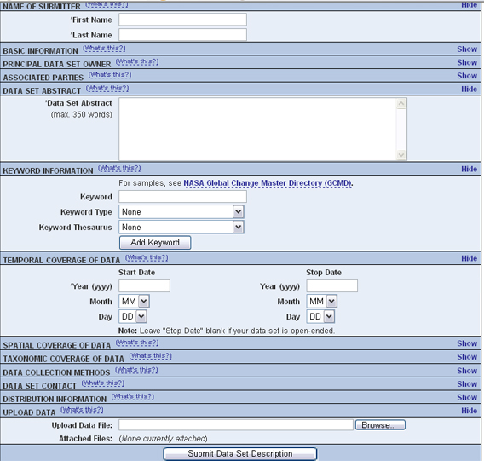
Figure 2.1: An example installation of the Register's web interface. Customize the displayed and required form fields with the Skins Configuration settings.

To install the Registry:

- Download and extract the Metacat Source Distribution. (See section 2.2.1.2 for step-by-step instructions for downloading and extracting source)

- Build the Metacat Perl client library:
cd $METACAT/src/perl/Metacat
perl Makefile.PL
sudo make
sudo make install

- Install the required system libraries using Ubuntu/Debian (skip down for instructions for using Red Hat)

- Install the libraries
sudo apt-get install ant libappconfig-perl libxml-libxml-perl libxml-libxslt-perl \
libtemplate-perl libcgi-session-perl libdigest-sha1-perl libnet-ldap-perl \
libterm-readkey-perl libxml-dom-perl libsoap-lite-perl -y

- Install one more package using cpan
sudo cpan -i Config::Properties
sudo cpan -i scalar::util

Instructions for Red Hat
  - Install the libraries
sudo yum install gcc libxml2-devel libxslt-devel ant –y

  - Install CPAN, which allows us to install the Perl dependencies for the registry and account management parts of Metacat. If asked to manually configure cpan, type 'no' and CPAN will be setup with its default values.
sudo yum install perl-CPAN
sudo cpan

  - You should now see a prompt which looks like:
cpan>

  - The rest of the commands assume you're inside of CPAN. Let's get the most recent version of the CPAN software. Just press return after any prompts you receive during this process.
install Bundle::CPAN
reload cpan

- Install the required modules. Here we're installing an old LibXSLT, as the current one requires a newer libxslt than is available on Redhat 4 & 5. Again, just answer 'yes' to any questions.

install AutoLoader
install CGI
install CGI::SEssion
install LWP::UserAgent
install Net::LDAP
install Template
install URI
install MSERGEANT/XML-LibXSLT-1.58.tar.gz

- Double check that Metacat's temporary folder, application.tempDir, is writable by the apache user, usually www-data or apache.

- Visit the resulting URL:
http://localhost/knb/cgi-bin/register-dataset.cgi?cfg=nceas

If everything worked correctly, you should see the Registry home page (Figure 2.2): 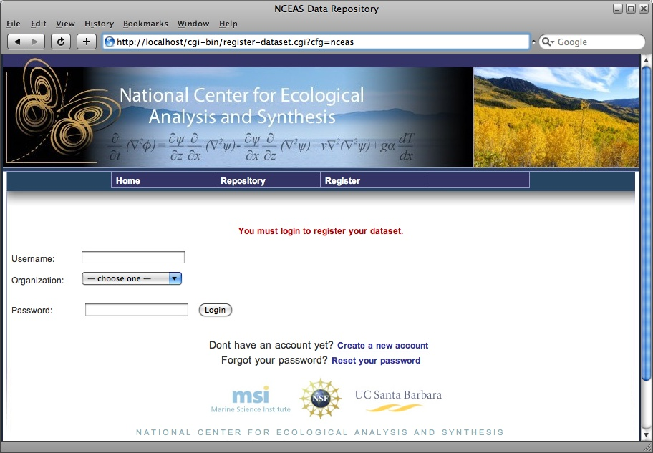
Figure 2.2: An example of the Restistry home page.

LSID Server

Metacat's optional LSID server allows Metacat to use a globally accepted standard for identifying biological entities instead of a proprietary scheme. LSID's were designed to identify complex biological entities with short identifiers (much like DOIs in publishing) that are both computer and human readable. The format of an LSID is:

urn:lsid:<Authority>:<Namespace>:<ObjectID>[:<Version>]
e.g., urn:lsid:sulphur.ecoinformatics.org:tao:12039:1

When you enable the Metacat LSID support, you can use LSID clients (such as LSID Launchpad) and LSID notation to query Metacat for data and metadata. LSID notation can be used directly in Metacat HTTP queries as well. For example, a data package with an ID tao.12039.1 that is stored in a Metacat available at: http://qtz.homelinux.com:9999 can be accessed by the following HTTP Metacat queries:

http://qtz.homelinux.com:9999/authority/data?lsid=urn:lsid:sulphur.ecoinformatics.org:tao:12039:1
(To return the data)

http://qtz.homelinux.com:9999/authority/metadata?lsid=urn:lsid:sulphur.ecoinformatics.org:tao:12039:1
(To return the metadata)

Notice that in the HTTP query strings, the periods in the data package ID have been replaced with colons. The authority (sulphur.ecoinformatics.org) must be properly configured by the Metacat administrator. Note: In order to configure the authority, you must have access to the DNS server for the Metacat domain. Further instructions are provided below.

To install and configure the LSID Server with Metacat:

- Copy Metacat's LSID WAR to the Tomcat webapps directory. The LSID WAR is called authority.war and can be found in the directory into which you extracted Metacat.
sudo cp <metacat_package_dir>/authority.war <tomcat_app_dir>

- Restart Tomcat:
sudo /etc/init.d/tomcat5.5 restart

- If you are running Tomcat behind the Apache server (the recommended configuration), set up and enable the authority service site configurations by typing:
sudo cp <metacat_package_dir>/authority <apache_install_dir>/sites-available
sudo a2ensite authority

- Restart Apache to bring in changes by typing:
sudo /etc/init.d/apache2 force-reload

- Modify the SRV record(s) on the DNS server for the domain hosting the Metacat:

I don't understand the instructions re SRV and build.properties.

Also notice the host urn attribute (urn:lsid:sulphur.ecoinformatics.org), this host needs to be set as a SRV record as DNS entry on the DNS server for ecoinformatics.org. To use LSID support in Metacat the Metacat administrator does need to have access to the DNS server for the domain hosting the Metacat so that he/she can modify the SRV record(s). The Metacat build.properties LSID attributes for the above example are:
authority.context=authority
config.lsidauthority=sulphur.ecoinformatics.org [[these set where?]]
** the SRV record for sulphur.ecoinformatics.org points to qtz.homelinux.com on port 9999

Troubleshooting

If you see something like:
java.lang.InternalError: Can't connect to X11 window server using 'yourservanme:0.0' as the value of the DISPLAY variable.

You should add this line:
JAVA_OPTS="-Djava.awt.headless=true $JAVA_OPTS"

at the first line of the catalina.sh file in the Tomcat bin directory. The reason is that GeoServer uses X11 windows to draw graphics.

Installing on Windows
THINGS I THINK MAY NOT BE SUPPORTED ON WINDOWS: Registry? Data Upload? Anything else?

Downloading Metacat

Before installing Metacat, please ensure that all required software is installed and running correctly (see Section 2.3.2). To obtain a Metacat WAR file, which is used when installing the Metacat servlet:

- Browse to the KNB Software Download Page. In the Metacat section, select the link that looks like: metacat-bin-X.X.X.zip, where X.X.X is the latest version of Metacat.
- Choose to download and Save the file locally.
- Extract the Metacat package files using your Windows zip utility. You should see a WAR file and several supporting files (we will only use the WAR file when installing Metacat).

Note: The location where these files were extracted will be referred to as the <metacat_package_dir> for the remainder of this documentation.

Installing Required Software

Before you can install and run Metacat, you must ensure that a recent Java SDK,
PostgreSQL and Tomcat are installed, configured, and running correctly.

Java 5.0

To run Metacat, you need a recent Java SDK. The latest Metacat release (1.8.1) has been tested most extensively with J2SE 5.0, and this is the recommended version; J2SE 1.4.2 or later is required. Make sure that the JAVA_HOME environment variable is properly set and that both java and javac are on your PATH.

To download and install Java:

- Browse to: http://java.sun.com/javase/downloads/index_jdk5.jsp and follow the instructions to download JDK 5.0 Update 17.
- Run the downloaded installer to install Java.
- Set the JAVA_HOME environment variable: In "My Computer" properties, go to "advanced settings > environment variables". Add:

System Variable: JAVA_HOME C:\Program Files\Java\jdk1.5.0_17

Tomcat

We recommend that you install Tomcat version 5.5.

To download and install Tomcat:

- Browse to: http://tomcat.apache.org/download-55.cgi
- Download the Tomcat core zip file
- Extract Tomcat files to C:\Program Files\tomcat using the windows zip utility.

NO METACAT STARTUP SCRIPT?

PostgreSQL Database

Metacat can be run with any SQL92-compliant RDBMS, but it has been most widely tested with PostgreSQL. Instructions for installing and configuring PostgreSQL for use with Metacat are included in this section.

To download and install PostgreSQL:

  - Browse to http://www.postgresql.org/download/windows
  - Download the one-click installer
  - Run the installer
  - Edit C:\Program Files\PostgreSQL\8.3\data and add:
host metacat metacat 127.0.0.1 255.255.255.255 password
- Create a super user. At the command line, go to C:\Program Files\PostgreSQL\8.3\bin and run:
createdb -U postgres metacat (enter super user password)

- Log in to postgres:
psql -U postgres metacat (enter super user password)

- Create a Metacat user:
CREATE USER metacat WITH UNENCRYPTED PASSWORD 'your_password'

- Exit postgres:
\q

- Restart postgres from the start menu by selecting:
run start/All Programs/PostgreSQL 8.3/Stop Server
run start/All Programs/PostgreSQL 8.3/Start Server

- Test the installation by logging in as Metacat user:
psql -U metacat -W -h localhost metacat

- Exit postgres:
\q

The Metacat servlet automatically creates the required database schema. For more information, please see Section 3.

Installing Metacat

New Install

Before installing Metacat, please ensure that all required applications are installed, configured to run with Metacat, and running correctly (see section 2.3.2). If you are upgrading an existing Metacat servlet, please skip to Section 2.3.3.2.

To install a new Metacat servlet:

- Create the Metacat base directory at:
C:/Program Files/metacat
- Copy the Metacat WAR file to Tomcat (for information about obtaining a Metacat WAR file, see Section 2.3.1):
copy <metacat_package_dir>\knb.war C:\Program Files\tomcat\webapps

- Restart Tomcat:
sudo /etc/init.d/tomcat5.5 restart

Congratulations! You are now ready to configure Metacat. Please see Section 3, Configuring Metacat for more information.

Upgrade

To upgrade an existing Metacat installation:

- Download and extract the new version of Metacat. For more information about downloading and extracting Metacat, please see section 2.3.1.

- Back up the existing Metacat installation. Although not required, we highly recommend that you back up your existing Metacat before installing a new one. You can do so by copying:
<web_app_dir>/knb to <web_app_dir>/knb.<yyyymmdd>
<web_app_dir>/knb.war to <web_app_dir>/knb.war.<yyyymmdd>
- Copy the new Metacat WAR file in to Tomcat applications directory:
sudo cp knb.war to C:\Program Files\tomcat\webapps

- Restart Tomcat:
C:\Program Files\tomcat\shutdown.bat
C:\Program Files\tomcat\startup.bat

Congratulations! You are now ready to configure Metacat. Please see Section 3, Configuring Metacat for more information.

Configuring Metacat

When Metacat (Tomcat) is started, the Metacat servlet checks to see if it is configured. If not, you will be automatically sent to the configuration pages.

If the installation is new, or the previous version is before 1.9.0, you will need to pay close attention to the configuration values. If you have upgraded Metacat, and the previous version is 1.9.0 or later, Metacat will pull existing configuration settings from a backup location. You should still verify that the values are correct.

To access your Metacat, open a Web browser and type:
http://<your_context_url>

Where <your_context_url> is the URL of the server hosting the Metacat followed by the name of the WAR file (i.e., the application context) that you installed. For instance, the context URL for the KNB Metacat is: http://knb.ecoinformatics.org/knb

You can always open the configuration screen from within Metacat by typing:

http://<your_context_url>/admin

Initial Configurations

Before you can log in to the Metacat and configure it, you are required to confirm Metacat's back-up location and authentication configuration (if not already configured). Metacat will automatically attempt to locate an existing back-up directory, but you may need to correct the value or specify a directory (if the installation is new, or if Metacat was unable to determine the location of an existing back-up directory). The authentication configuration is required for logging in to the Metacat and for defining administrative accounts. Instructions for changing the authentication configuration without authentication are included in section 3.1.3.

Back-up Configuration

To preserve its configuration settings, Metacat backs up all configurations to a directory outside the application directories. Because a new installation/upgrade does not know where this external directory is, Metacat uses a discovery algorithm to locate it. If Metacat can identify a backup directory, the location of that directory pre-populates the field on the Backup Directory Configuration screen (Figure 3.1). If the pre-populated value is incorrect, change it to the correct directory.

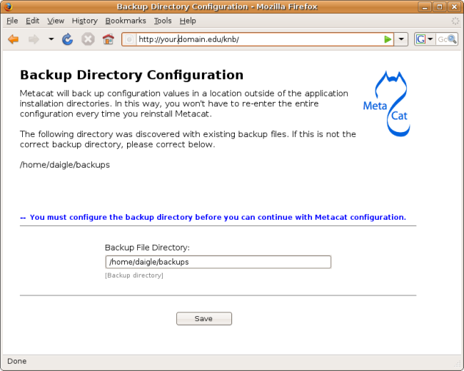
Figure 3.3: Configuring the Backup Directory.

Authentication Configuration

Whether you are installing or upgrading the Metacat servlet, you will automatically be sent to the Authentication Configuration page. You can also reach the Authentication Configuration page from a running Metacat by typing: http://<your_context_url>/admin

Metacat uses LDAP as its primary authentication mechanism, but you can define your own authentication mechanism by creating a Java class that implements AuthInterface.
Required configuration values are: Authentication Class, Authentication URL, Authentication Secure URL, and Metacat Administrators (Figure 3.2). Make sure that your user account information is entered into the Metacat Administrators field. You will not be allowed to continue with configuration if this is missing.

If you change the authentication settings, you must log in as an administrator and restart Metacat to put them into effect.

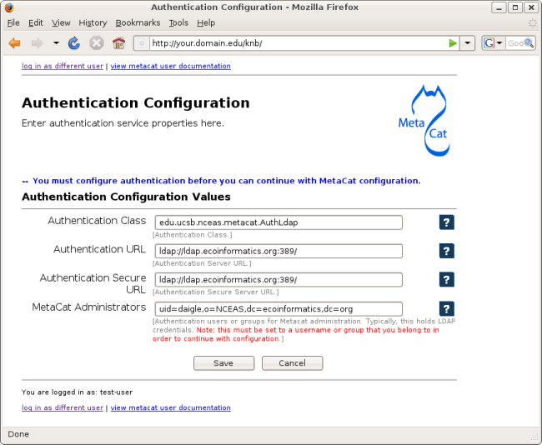
Figure 3.4: Configuring Authentication Values.

Changing Authentication Configuration without Authentication

If you need to change or add authentication information and cannot authenticate using the existing authentication settings (e.g., the existing Metacat administrator is no longer available or you forgot the administrator password), you must edit the Metacat configuration file by hand. This insures that only a person who has access to the Metacat server and the configuration files on that server will be able to change the administrator accounts.

To edit the authentication configuration file:

- Stop Tomcat and edit the Metacat properties file in the Metacat context directory inside the Tomcat application directory. The Metacat context directory is the name of the application (usually knb):

<tomcat_app_dir>/<context_dir>/WEB-INF/metacat.properties

- Change the following properties appropriately:
auth.administrators - a colon separated list of administrators
auth.url - the authentication server URL
auth.surl - the authentication secure server URL

- Save the metacat.properties file and start Tomcat.

Logging in to the Metacat

In order to configure Metacat, you must log in with an administrative account that has been configured in the Authentication Configuration settings (see Section 3.1.2). If you did not set up the correct administrative user there, you must change the authentication configuration by hand (see section 3.1.3 for instructions) before you can log in.

In the log-in screen (Figure 3.3) enter your user name and password and click the "Login" button.

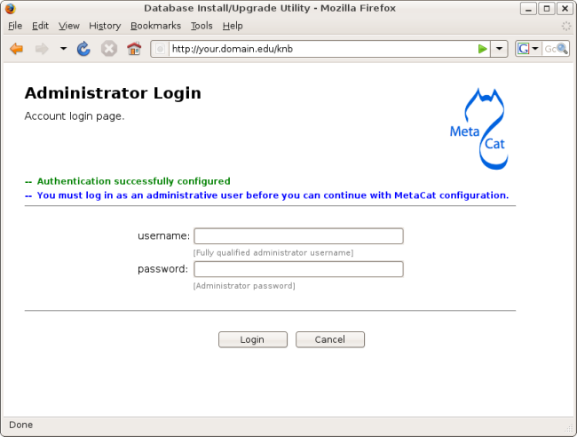
Figure 3.5: Logging in to Metacat

Required Configurations

All required Metacat settings can be accessed from the Metacat Configuration screen (Figure 3.4), which becomes available after the initial configurations (see section 3.1) have been specified and an authorized administrator logs in.

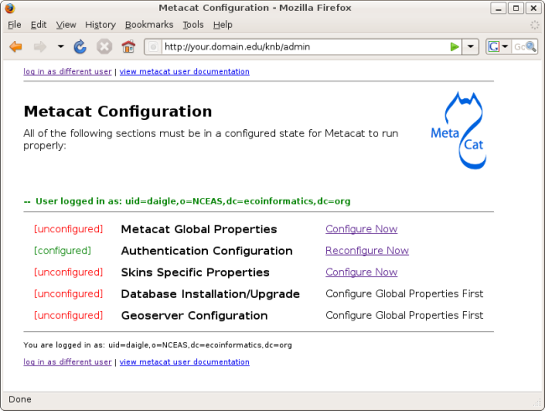
Figure 3.6: Required Metacat configurations.

The configuration settings are grouped into five sections (Metacat Global Properties, Authentication Configuraion, Skins Specific Properties, Database Installation/Upgrade, Geoserver Configuration), each of which is listed with its current status (Table 3.1)

Status | Description
[unconfigured] | The section has yet to be configured
[configured] | The section has been configured.
[bypassed] | Used only for the Geoserver configurations. The administrator can choose not to configure the Geoserver user/password.
Table 3.2: Possible configuration statuses.

To the right of each configuration section is one of the following options: Configure Now, Reconfigure Now, Configure Global Properties First, or Version:X.X.X. If the option is linked (e.g., Configure Now or Reconfigure Now), you can select the link to open the associated configuration settings and add or edit them, respectively. If the option is not linked (e.g., Configure Global Properties First), the settings cannot be specified until the global properties are set. Once the global properties are configured, the option to configure this section becomes available. The Version:X.X.X option is used only for the Database Installation/Upgrade section. If the database schema version detected by Metacat matches the application version (e.g., 1.9.1), then no further database configuration is required.

All settings must be in a configured or bypassed state in order to run Metacat (Figure 3.5). For new installations or upgrades, click the "go to metacat" link that appears after configuration is complete to go directly to Metacat. Note that Metacat indexes at start-up time, so the initial start-up may take some time depending on the amount of data in your database. If you are reconfiguring a running version of Metacat, you must restart the Tomcat server for the changes to take effect.

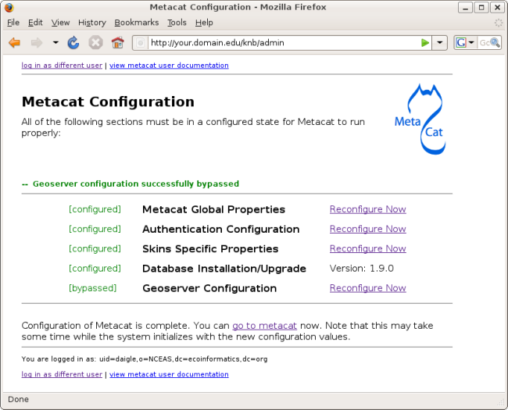
Figure 3.7: The Metacat settings as they appear after configured.

Global Properties (server, ports, etc)

The Metacat configurations included under Global Properties represent the bulk of the settings required to run Metacat (Figure 3.6). Click a blue question-mark icon beside any setting for detailed instructions.

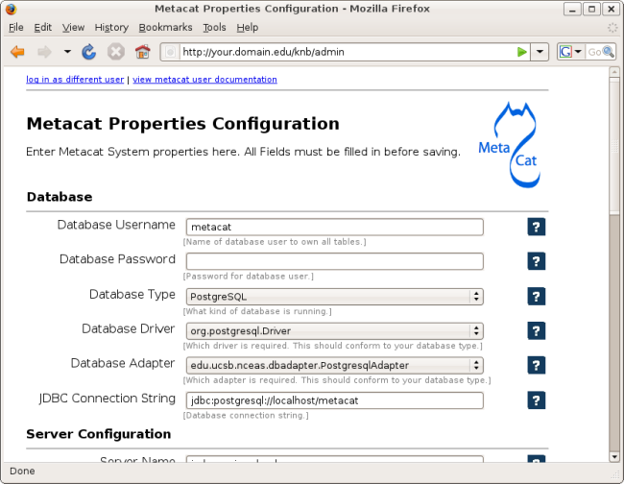
Figure 3.8 Setting Metacat's Global Properties.

When you save global properties, Metacat also saves a back-up file that is located in
/var/metacat/.metacat (on Linux systems) or
C:\Program Files\metacat\.metacat (on Windows systems). When you update Metacat, the system automatically locates the back-up file so you do not have to re-enter the configuration settings.

The first time you install Metacat, the system attempts to automatically detect the values for a number of settings (Table 3.2). It is important to ensure that these values are correct.

Property | Description
Metacat Context | The name of the deployed Metacat WAR file (minus the .war extension). E.g., "knb"
Server Name | The DNS name of the server hosting Metacat, not including port numbers or the "http://" header.
HTTP Port | The non-secure port where Metacat will be available.
HTTP SSL Port | The secure port where Metacat will be available.
Deploy Location | The directory where the application is deployed.
Table 3.3: Configuration settings that Metacat will automatically detect.

Authentication Configuration

Because you must specify the Authentication settings before you can access the main configuration page, the settings will always be configured. If you wish to change the authentication settings, you must restart Metacat to put the changes into effect. For more information about the Authentication configurations, please see Section 3.1.2.

Skins Configuration (look & feel)

Customizing the look and feel of Metacat's Web interface is done via skins, which are applied in the Skins Configuration section. If you have installed the optional Registry, which provides a Web interface for creating, editing, and submitting content to the Metacat, you can also choose which form fields appear in that interface and which are required. Note that if you do not have a custom skin AND you are not using the Registry, you can simply save the default configuration.

How does one get a customized skin?

If your Metacat has a customized skin, it will appear as a choice in the Skins Configuration settings (Figure 3.7).

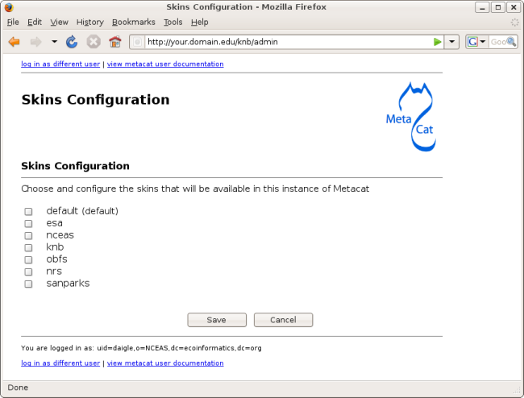
Figure 3.9: Configuring Metacat skins.

Select the checkbox next to your customized skin and click the 'Make <skin_name> default" radio button. If you do not have a custom skin, select the "default" skin. Once you have selected a skin, Metacat will open a list of options that apply to the Registry interface (Figure 3.8).

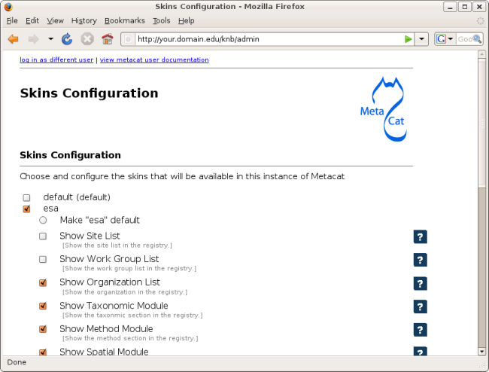
Figure 3.10: Configuring the lists and modules that will be displayed by the Registry.

Select the lists and modules that you would like to appear in the Registry form-interface by checking the box beside each. When you save the configuration, the customized interface will appear to site visitors.

Database Configuration

Because the Database Configuration is dependent on values specified in the Global Configuration section, the link to these settings does not become active until after the global settings have been saved. Once the global settings have been saved,
Metacat automatically detects the database schema version and upgrades it if necessary (and with your permission).

New Installation

If Metacat determines that your database is new, the Database Install/Upgrade utility lists the SQL scripts that will run in order to create a database schema for the new version of Metacat (Figure 3.9).

If the database is not new, or if you have any questions about whether it is new or not, choose Cancel and contact support at knb-software@nceas.ucsb.edu.

When you choose Continue, Metacat runs the listed scripts and create the database schema.

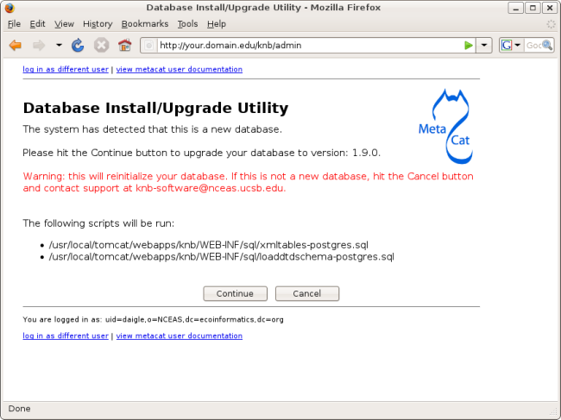
Figure 3.11: Database Install/Upgrade for new databases.

Upgrade

If Metacat identifies a previous database schema, the Database Install/Upgrade utility notes the existing version and lists the SQL scripts that will run in order to update the schema for the new version of Metacat (Figure 3.10).

If the detected schema version is incorrect, or if you have any questions about whether it is correct or not, click the Cancel button and contact support at knb-software@nceas.ucsb.edu.

When you choose to continue, Metacat runs the listed scripts and updates the database schema.

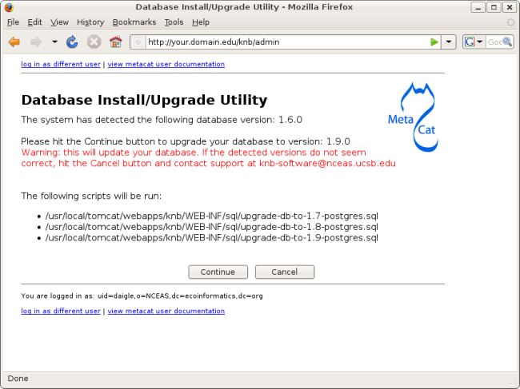
Figure 3.12: Upgrading an existing database.

Geoserver Password Configuration (Highly Recommended)

Metacat comes bundled with a Web Mapping Service called Geoserver, which converts spatial data into Web-deliverable map images. Geoserver installs with a default administrative username and password. We highly recommend that you change the default log-in information so that only local administrators can make changes to your Geoserver. For more information about Geoserver, see Section 5.

When you choose the Geoserver Configuration link from the main configuration screen, Metacat will prompt you for a new user name and password (Figure 3.11). After you enter the new credentials, the Metacat server contacts the embedded Geoserver server and updates the log-in settings.

If you wish to reset the Geoserver credentials at another time, click the Bypass button. The Geoserver will remain configured with the default user name and password, and the main configuration screen will display the "bypassed" status beside the Geoserver settings. You will be able to run Metacat, just as if the settings were configured.

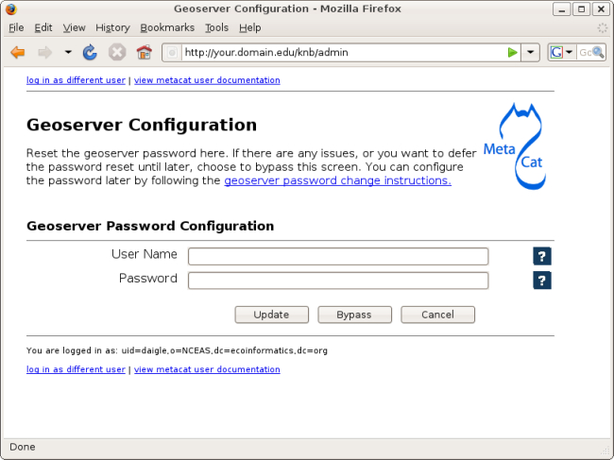
Figure 3.13: Resetting the Geoserver password.

Manual Geoserver Update

You can change the Geoserver username and password by directly logging in to the Geoserver. To configure the credentials manually:

- Go to the Geoserver admin page: <tomcat_app_dir>/<context_dir>/geoserver.jsp.
- Log in using the default username and password ( admin / geoserver )
- Navigate to the Password Change Page. Enter a new user and password and click Submit.
- Click Apply then Save to save your new password.

Note that once you change the Geoserver credentials manually, you cannot use the Metacat configuration tool to change it again (until a new Metacat upgrade or installation).

Optional Configuration

PROPERTIES NOT IN CONFIGURATION UTILITY??

Geoserver Configuration

Harvester Configuration

SAX Parsing ??— (Not sure where this goes/how used yet)

Set a default style-set (?) Qformat (html, xml, style-set) (Or is this in global now/mandatory?)
SKINS.

Replication

Accessing and Submitting Metadata and Data

The Metacat repository can be accessed and updated using a number of tools, including:

- the Registry, Metacat's optional Web interface
- user-created HTML forms and Web services
- existing clients, such as KNB's Morpho application, which is designed to help scientists create, edit, and manage metadata
- user-created desktop clients that take advantage of Metacat's Java API.

In this section, we will look at how to take advantage of these tools to customize Metacat for your user-base.

A Brief Note about How Information is Stored

Metacat stores XML files as a hierarchy of nodes, where each node is stored as records in database tables. Because many XML data schemas are broken up into multiple DTDs requiring multiple XML files that are related but stored separately in the system, the system uses "packages" to link related but separate documents. Packaged documents contain information that shows how they are related to eachother, essentially stating that file A has a relationship to file B, etc. A package file also allows users to link metadata files to the data files they describe. For more information about how XML documents and data are stored in Metacat, please see http://knb.ecoinformatics.org/software/metacat/metacatdb.html. For more information about packages, please see http://knb.ecoinformatics.org/software/metacat/packages.html.

Using the Registry

Metacat's optional Registry provides a simple Web-based interface for creating, editing, and submitting metadata to the Metacat repository (Figure 4.1). The interface includes help documentation, and can be customized using Metacat's configuration settings. The Registry also includes an administrative interface for managing LDAP user accounts, which is useful if you are using LDAP as your Metacat authentication system.

In order to install and run the Registry, you must be running Tomcat behind an Apache Web server (see Section 2.2.2.3 for information about installing and configuring Apache to run with Tomcat). You must also download a source distribution of Metacat. For more information about downloading and installing the Registry, please see Section 2.2.4.1.

Figure 4.14: An example installation of the Register's web interface. Customize the displayed and required modules with the Skins Configuration settings.

Once the Registry is installed, you can customize which modules (e.g., "Name of Submitter" or "Temporal Coverage of Data") are displayed and which are required using the Skins Configuration settings. See Section 3.3.3 for more information about using skins.

Using HTML Forms (the HTTP Interface)

Metacat's HTTP interface supports Get and Post requests and a variety of actions (Table 4.1) that facilitate information retrieval and storage. HTTP requests can be sent from any client application that communicates using the Web's HTTP protocol.

Supported Actions
Metacat supports get and post requests as well as actions for writing, querying, and reading stored XML. In addition, the HTTP interface includes functions for validating and transforming XML documents (Table 4.1).

Note that if Replication is enabled, Metacat recognizes several additional actions, included in Table 4.2. For more information about replication, please see Section 6.

Actions Supported by the Metacat Servlet
Action | Description and Parameters
delete | Delete the specified document from the database. For an example, please see Section 4.2.2.  docid - the docid of the document to delete
export | Exports a data package in a zip file.  docid - the docid of the package you wish to export
getaccesscontrol | Get the access control list (ACL) for the specified document.  docid - the docid of the document for which to get the ACL
getalldocids | Retrieve a list of all docids registered with the system.  scope - a string used to match a range of docids in a SQL LIKE statement.
getdataguide  DEPRECATED  Use getdtdschema instead. | Read a data guide for doctype.  doctype - the doctype for which to get the data guide
getdoctypes | Get all doctypes currently available in the Metacat Catalog System.  No parameters
getdtdschema | Read the DTD or XMLSchema file for the specified doctype.  doctype - the doctype for which DTD or XMLSchema files to read.
getlastdocid | Get the latest docid with revision number used by user.  username - the user's log-in name
getlog | Print a report from the Metacat event log.  ipaddress - the internet protocol address for the event  principal - the principal for the event (a username, etc)  docid - the identifier of the document to which the event applies  event - the string code for the event  start - beginning of date-range for query  end - end of date-range for query
getloggedinuserinfo | Get user info for the currently logged in user.  No parameters
getprincipals | Get all users and groups in the current authentication schema  No parameters
getrevisionanddoctype | Return the revision and doctype of a document. The output is String that looks like "rev;doctype"  docid - the docid of the document.
getversion - get Metacat version. | Return the current version of Metacat as XML.  No parameters
insert | Insert an XML document into the database. For an example, please see Section 4.2.2.  docid - the user-defined docid to assign to the new XML document.  doctext - the text of the XML document to insert
insertmultipart | Insert an XML document using multipart encoding into the database.  docid - the user-defined docid to assign to the new XML document.  doctext - the text of the XML document to insert
isregistered | Check if an individual document exists in either the xml_documents or xml_revisions tables. For more information about Metacat's database schema, please see: http://knb.ecoinformatics.org/software/metacat/metacatdb.html  docid - the docid of the document.
login | Log the user in.  username - the user's login name  password - the user's password
logout | Log the current user out and destroy the associated session.  No parameters
protocoltest | Test the protocol handlers installed for metacat:// URLs.  url - the URL to test against the protocol handler
query | Perform a free text query. For an example, please see Section 4.3.3.  returndoctype - the doctype to use for your Package View. For more information about packages, see http://knb.ecoinformatics.org/software/metacat/packages.html  qformat - the format of the returned result set. Possible values are html or xml.  querytitle - OPTIONAL - the title of the query  doctype - OPTIONAL - if doctype is specified, the search is limited only to the specified doctype(s). (e.g., eml://ecoinformatics.org/eml-2.0.1 and/or eml://ecoinformatics.org/eml-2.0.0) If no doctype element is specified, all document types are returned  returnfield - a custom field to be returned by any hit document.  operator - the Boolean operator to apply to the query. Possible values are: union or intersect  searchmode - the type of search to be performed. Possible values are: contains, starts-with, ends-with, equals, isnot-equal, greater-than, less-than, greater-than-equals, less-than-equals.  anyfield - a free-text search variable. The value placed in this parameter will be searched for in any document in any node.  pagesize – the number of search results to display on each search results page (e.g., 10). Used with pagestart. See section 4.3.4 for an example.  pagestart – the displayed search results page (e.g, 1). Used with pagesize. See section 4.3.4 for an example.
read | Get a document from the database and return it in the specified format. See section 4.3.5 for an example.  docid - the docid of the document to return  qformat - the format to return the document in. Possible values are: html, xml
readinlinedata | Read inline data only. WHAT IS INLINE DATA? When used?  inlinedataid - the id of the inline data to read
setaccess | Change access permissions for a user on a specified document.  docid - the docid of the document to be modified.  principal - the user or group whose permissions will be modified  permission - the permission to set (read, write, all)  permType - the type of permission to set (allow, deny)  permOrder - the order in which to apply the permission (allowFirst, denyFirst)
spatial_query | Perform a spatial query. These queries may include any of the queries supported by the WFS / WMS standards.  xmax - max x spatial coordinate  ymax - max y spatial coordinate  xmin - min x spatial coordinate  ymin - min y spatial coordinate
squery | Perform a structured query. For an example, please see Section 4.3.3.  query - the text of the pathquery document sent to the server
update | Overwrite an XML document with a new one and give the new one the same docid but with the next revision number. For an example, please see Section 4.2.2.  docid - the docid of the document to update  doctext - the text with which to update the XML document
upload | Upload (insert or update) a data file into Metacat. Data files are stored on Metacat and may be in any format (binary or text), but they are all treated as if they were binary.  docid - the docid of the data file to upload  datafile - the data file to upload
validate | Validate a docid against its DTD.  docid - the docid of the document to validate  valtext - the DTD by which to validate this document
Table 4.4 Supported actions and associated parameters.
MetacatReplication Parameters : HAVE NOT YET DECIDED WHERE THIS SHOULD GO. HERE, OR WITH REPLICATION? Probably here.
Action | Supplemental Parameters | Description
forcereplicate | server - The server to which this document is being sent  docid - The docid of the document to send  dbaction - DEFAULTS TO UPDATE - The action to perform on the document. INSERT or UPDATE. | Force this server to get docid from the remote host.
getall | none | Forces the local server to check all known servers for updated documents.
getcatalog | none | Sends the contents of the xml_catalog table encoded in XML.
getlock | docid - the docid to get the lock for  updaterev - the revision number of docid | Request a lock on docid.
gettime | none | Return the local time on this server.
servercontrol | subaction - The replication control to be performed. Possible values:  add - add a new server to the replication list  delete - remove a server from the replication list  list - list all of the servers currently in the server list  replicate - a boolean flag (1 or 0) which determines if this server is to copy files from the newly added server.  server - the server to add/delete | Perform subaction on the Replication daemon.
read | docid - the docid to read | Sends docid to the remote host.
start | rate - DEFAULTS TO 1000 - The rate (in seconds) at which you want the replication daemon to check for updated documents. The value cannot be less than 30. | Start the Replication daemon with a time interval of deltaT.
stop | none | Stop the Replication daemon.
update | none | Send a list of all documents on the local server along with their revision numbers.

Inserting, Updating, and Deleting XML and Data Documents

Adding, editing, and deleting XML documents in Metacat can be accomplished using the insert, update, and delete actions, respectively.

insert: | Insert a new XML or data document into Metacat. You must specify a document ID.
update: | Update an existing Metacat document. The original document is archived, then overwritten.
delete: | Archive a document and move the pointer in xml_documents to xml_revisions, effectively "deleting" the document from public view, but preserving the revision for the revision history.

The following is an example of a Web form (Figure 4.2) that can perform all three tasks. The HTML code is included below the screenshot: WHAT SHOULD THE URL FOR THIS PAGE LOOK LIKE WHEN DEPLOYED? This is an example from existing docs, but I'm not yet sure how/where it is best used/implemented.
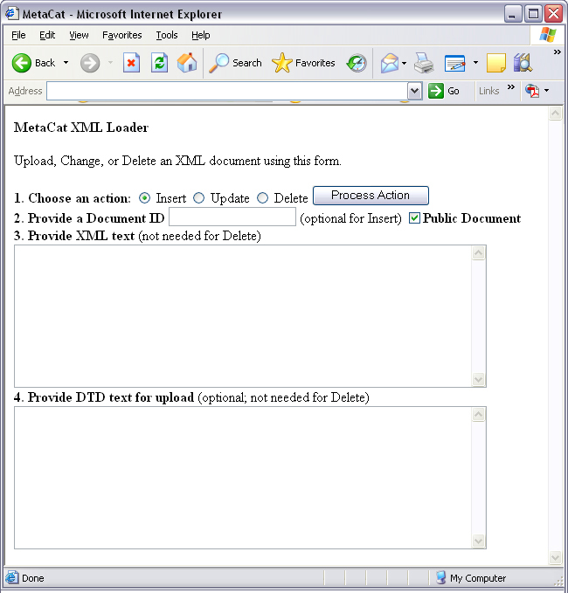
Figure 4.15: An example of a Web form used to insert, delete, or update XML documents in Metacat.

<html>
<head>
<title>MetaCat</title>
<link rel="stylesheet" type="text/css" href="metacat/style/rowcol.css">
</head>
<body class="emlbody">
<b>MetaCat XML Loader</b>
<p>
Upload, Change, or Delete an XML document using this form.
</p>
<form action="http://dev.nceas.ucsb.edu/metacat/servlet/metacat" method="POST">
<strong>1. Choose an action: </strong>
<input type="radio" name="action" value="insert" checked> Insert
<input type="radio" name="action" value="update"> Update
<input type="radio" name="action" value="delete"> Delete
<input type="submit" value="Process Action">
<br />
<strong>2. Provide a Document ID </strong>
<input type="text" name="docid"> (optional for Insert)
<input type="checkbox" name="public" value="yes" checked><strong>Public Document</strong>
<br />
<strong>3. Provide XML text </strong> (not needed for Delete)
<textarea name="doctext" cols="65" rows="15"></textarea><br/>
<strong>4. Provide DTD text for upload </strong> (optional; not needed for Delete)
<textarea name="dtdtext" cols="65" rows="15"></textarea>
</form>
</body>
</html>
Figure 4.16: HTML code used to generate the form in Figure 4.2.

Searching Metacat

To search Metacat use the query or squery actions.

query: | Perform a free text query. Specify the returndoctype, qformat, returnfield, operator, searchmode, anyfield, and (optionally) a querytitle and doctype.
squery: | Perform a structured query by submitting an XML pathquery document to the Metacat server.

When Metacat receives a query via HTTP (Figure 4.4), the server creates a "pathquery" document, which is an XML document populated with the specified search criteria (Figure 4.6). The pathquery document is then translated into SQL statements that are executed against the data base. Results are translated into an XML "resultset" document, which can be returned as XML or transformed into HTML and returned (specify which you would prefer with the returnfield parameter). You can also opt to submit a pathquery document directly, using an squery action.

EXISTING EXAMPLE OF HTML FORM I CAN USE HERE?

Figure 4.17: Example of a search form?

SAMPLE FORM??
WOULD BE NICE, I THINK, TO INCLUDE AN EXAMPLE OF THE FORM CODE/HOW THE SEARCH PARAMETERS CAN BE IMPLEMENTED THAT CAN BE CUT AND PASTED AND CUSTOMIZEDcut and pasted. E

Figure 4.18: Form code that generates the form in Figure 4.4.

Metacat's pathquery document can query specific fields of any XML document. The pathquery can also be used to specify which fields from each hit are returned and displayed in the search result set (Figure 4.6)

<pathquery version="1.0">
<meta_file_id>unspecified</meta_file_id>
<querytitle>unspecified</querytitle>
<returnfield>dataset/title</returnfield>
<returnfield>keyword</returnfield>
<returnfield>originator/individualName/surName</returnfield>
<returndoctype>eml://ecoinformatics.org/eml-2.0.1</returndoctype>
<returndoctype>eml://ecoinformatics.org/eml-2.0.0</returndoctype>
<querygroup operator="UNION">
<queryterm casesensitive="false" searchmode="contains">
<value>Plant</value>
<pathexpr>dataset/title</pathexpr>
</queryterm>
<queryterm casesensitive="false" searchmode="contains">
<value>plant</value>
<pathexpr>keyword</pathexpr>
</queryterm>
</querygroup>
</pathquery>

Figure 4.19: An example of a pathquery document

Each <returnfield> parameter specifies a field that the data base will return (in addition to the fields Metacat returns by default) for each search result.

The <returndoctype> field limits the type of returned documents (e.g., eml://ecoinformatics.org/eml-2.0.1 and/or eml://ecoinformatics.org/eml-2.0.0). If no returndoctype element is specified, all document types are returned.

A <querygroup> creates an AND or an OR statement that applies to the nested <queryterm> tags. The querygroup operator can be UNION or INTERSECT. A <queryterm> defines the actual field (contained in <pathexpr> tags) against which the query (contained in the <value> tags) is being performed. See Figure 4.6 for an illustration.

The <pathexpr> can also contain a document type keyword contained in <returndoc> tags. The specified document type applies only to documents that are packaged together (e.g., a data set and its corresponding metadata file). If Metacat identifies the search term in a packaged document, the servlet will check to see if that document's type matches the specified one. If not, Metacat will check if one of the other documents in the package matches. If so, Metacat will return the matching document. For more information about packages, please see Packages and Relations.

After Metacat has processed a Pathquery document, it returns a resultset document (Figure 4.7)
<resultset>
<query>
<pathquery version="1.0">
<meta_file_id>unspecified</meta_file_id>
<querytitle>unspecified</querytitle>
<returnfield>dataset/title</returnfield>
<returnfield>keyword</returnfield>
<returnfield>originator/individualName/surName</returnfield>
<returndoctype>eml://ecoinformatics.org/eml-2.0.1</returndoctype>
<returndoctype>eml://ecoinformatics.org/eml-2.0.0</returndoctype>
<querygroup operator="UNION">
<queryterm casesensitive="false" searchmode="contains">
<value>Datos</value>
<pathexpr>dataset/title</pathexpr>
</queryterm>
<queryterm casesensitive="false" searchmode="contains">
<value>plant</value>
<pathexpr>keyword</pathexpr>
</queryterm>
</querygroup>
</pathquery>
</query>

<document>
<docid>nceas.44.1</docid>
<docname>resource</docname>
<doctype>eml://ecoinformatics.org/eml-2.0.1</doctype>
<createdate>2001-01-12 16:12:06.0</createdate>
<updatedate>2001-01-12 16:12:06.0</updatedate>
<param name="dataset/title">Datos Meteorologicos</param>
<param name="keyword">intertidal</param>
<param name="originator/individualName/surName">Smith</param>
</document>

<document>
<docid>nceas.42.1</docid>
<docname>resource</docname>
<doctype>eml://ecoinformatics.org/eml-2.0.1</doctype>
<createdate>2001-01-12 16:11:31.0</createdate>
<updatedate>2001-01-12 16:11:31.0</updatedate>
<param name="dataset/title">Ocean Surface Temperature</param>
<param name="keyword">Plant</param>
<param name="originator/individualName/surName">Henry</param>
</document>
.....
</resultset>

Figure 4.20: An example of a resultset document.

When Metacat returns a resultset document, the servlet always includes the pathquery used to create it. The pathquery XML is contained in the <query> tag, the first element in the resultset.

Each XML document returned by the query is represented by a <document> tag. By default, Metacat will return the docid, docname, doctype, doctitle, createdate and updatedate for each search result. If the user specified additional return fields in the pathquery using <returnfield> tags (e.g., dataset/title to return the document title), the additional fields are returned in <param> tags.

Metacat can return the XML resultset to your client as either XML or HTML.

Paged Query Return

Dividing large search result sets over a number of pages speeds load-time and makes the result sets more readable to users (Figure 4.8). To break your search results into pages, use the query action's optional pagestart and pagesize parameters. The pagesize parameter indicates how many results should be returned for a given page. The pagestart parameter indicates which page you are currently viewing.

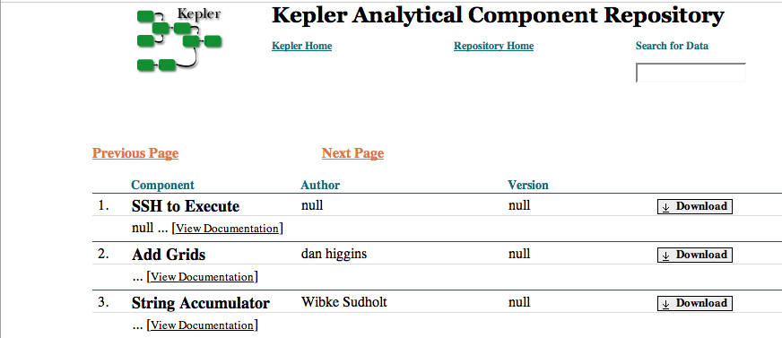
Figure 4.21: An example of paged search results. Metacat generates the "Previous Page" and "Next Page" links. To see this interface in action, go to http://library.kepler-project.org/kepler/.

When a paged query is performed, the query's resultset contains four extra fields: pagestart, pagesize, nextpage, and previouspage (Figure 4.9). The nextpage and previouspage fields help Metacat generate navigational links in the rendered resultset using XSLT to transform the XML to HTML.

<resultset>
<pagestart>1</pagestart>
<pagesize>10</pagesize>
<nextpage>2</nextpage>
<previouspage>0</previouspage>
<query>
...
</query>
<document>...</document>
<document>...</document>
</resultset>
Figure 4.22 An example of an XML resultset that include support for page breaks. The pagestart parameter will always indicate the page you are currently viewing.

The HTML search results displayed in Figure 4.8 were rendered using Kepler's XSLT, which can be found in lib/style/skins/kepler. Kepler's XSLT uses the four extra resultset fields to render the "Next" and "Previous" links (Figure 4.10).

<a href="metacat?action=query&operator=INTERSECT&enableediting=false&anyfield=actor&qformat=kepler&pagestart=0&pagesize=10">Previous Page</a>

<a href="metacat?action=query&operator=INTERSECT&enableediting=false&anyfield=actor&qformat=kepler&pagestart=2&pagesize=10">Next Page</a>
Figure 4.23: The HTML Next and Previous links generated by Metacat using Kepler's XSLT. Note that the current page is 1, and the previous (page 0) and next (page 2) pages are indicated by the values of the pagestart parameter.

Reading Data and MetaData

To read data or metadata from Metacat, use the read action. The read action takes two parameters: docid, which specifies the document ID of the document to return, and qformat, which specifies the return format for the document (html or xml, or the name of a configured style-set). If qformat is set to xml, Metacat will return the XML document untransformed. If the return format is set to html, Metacat will transform the XML document into HTML using the default XSLT style sheet (specified in the Metacat configurations). If the name of a style-set is specified, Metacat will use the XSLT styles specified in the set to transform the XML. For more information about configuring style sheets and style sets, see XXX.

Note that the read action can be used to read both data files and metadata files. To read a data file, you could use the following request:

http://server.domain.com/metacat?action=read&docid=nceas.55

Where nceas.55 is the docid of the data file.

Using Morpho

Morpho is a desktop tool created for ecologists to facilitate the creation, storage, and retrieval of metadata. Morpho interfaces with any Metacat server, allowing users to upload, download, store, query and view relevant metadata and data using the network. Users can authorize the public or only selected colleagues to view their data files.

Morpho is part of the Knowledge Network for Biocomplexity (KNB), a national network intended to facilitate ecological and environmental research on biocomplexity. For more information about Morpho, please see http://knb.ecoinformatics.org/morphoportal.jsp

Creating Your Own Client

Metacat's client API is available in Java and Perl (the Java interface is described in this section and further detailed in the appendix). The API allows client applications to easily authenticate users and perform basic Metacat operations such as reading metadata and data files; inserting, updating, and deleting files; and searching for packages based on metadata matches.

The Client API is defined by the interface edu.ucsb.nceas.metacat.client.Metacat, and all operations are fully defined in the javadoc documentation. To use the client API, include the metacat-client.jar, utilities.jar, and httpclient.jar in your classpath. After including these classes, you can begin using the API methods (Table 4.2).

Figure 4.11 displays a typical session for reading a document from Metacat.

String metacatUrl = "http://foo.com/context/metacat";
String username = "uid=jones,o=NCEAS,dc=ecoinformatics,dc=org";
String password = "neverHarcodeAPasswordInCode";
try {
Metacat m = MetacatFactory.createMetacatConnection(metacatUrl);
m.login(username, password);
Reader r = m.read("testdocument.1.1");
// Do whatever you want with Reader r
} catch (MetacatAuthException mae) {
handleError("Authorization failed:\n" + mae.getMessage());
} catch (MetacatInaccessibleException mie) {
handleError("Metacat Inaccessible:\n" + mie.getMessage());
} catch (Exception e) {
handleError("General exception:\n" + e.getMessage());
}
Figure 4.24: A typical session for reading a document from Metacat.

Operations provided by Client API
Method | Parameters and Throws | Description
delete | public String delete(String docid) throws InsufficientKarmaException, MetacatException, MetacatInaccessibleException; | Delete an XML document in the repository.
getNewestDoc  Revision | public int getNewestDocRevision(String docId) throws MetacatException; | Return the latest revision of specified the document from Metacat
getSessonId | public String getSessionId(); | Return the session identifier for this session.
insert | public String insert(String docid, Reader xmlDocument, Reader schema) throws InsufficientKarmaException, MetacatException, IOException, MetacatInaccessibleException; | Insert an XML document into the repository.
login | public String login(String username, String password) throws MetacatAuthException, MetacatInaccessibleException; | Log in to a Metacat server.
logout | public String logout() throws MetacatInaccessibleException, MetacatException; | Log out of a Metacat server.
query | public Reader query(Reader xmlQuery) throws MetacatInaccessibleException, IOException; | Query the Metacat repository and return the result set as a Reader.
read | public Reader read(String docid) throws InsufficientKarmaException, MetacatInaccessibleException, MetacatException; | Read an XML document from the Metacat server.
readInlineData | public Reader readInlineData(String inlinedataid) throws InsufficientKarmaException, MetacatInaccessibleException, MetacatException; | Read inline data from the Metacat server session.
setAccess | public String setAccess(String docid, String principal, String permission, String permType, String permOrder ); | Set permissions for an XML document in the Metacat repository.
setMetacatUrl | public void setMetacatUrl(String metacatUrl); | Set the MetacatUrl to which connections should be made.
setSessionId | public void setSessionId(String sessionId); | Set the session identifier for this session.
update | public String update(String docid, Reader xmlDocument, Reader schema) throws InsufficientKarmaException, MetacatException, IOException, MetacatInaccessibleException; | Update an XML document in the repository by providing a new version of the XML document.
upload | public String upload(String docid, File file) throws InsufficientKarmaException, MetacatException, IOException, MetacatInaccessibleException; | Upload a data document into the repository.
upload | public String upload(String docid, String fileName, InputStream fileData, int size) throws InsufficientKarmaException, MetacatException, IOException, MetacatInaccessibleException; | Upload a data document into the repository.
Table 4.5: Operations provided by client API. For more information, please see either the javadocs or the Appendix.

Metacat's Geoserver

GeoServer 1.4.0, an open source Web Mapping Service (WMS) written in Java, is bundled with Metacat and can be used (optionally) to render spatial data as web-deliverable maps (Figure 5.1). Metacat uses Community MapBuilder (a pure HTML/JavaScript application that uses AJAX and XSLT) to provide a web-based user interface for interacting with the generated maps. You can use any WMS-compatible client (e.g., ArcGIS, QGIS, JUMP, UDig, OpenLayers, Mapbender, Map Builder). Please note the mapping functionality is only supported for Metacat servlets running under Tomcat 5 or later.

IMPORTANT: Regardless of whether you plan on using the mapping functionality you should, for security purposes, configure GeoServer so that it doesn't use the default password. For instructions, please see Section 3.3.5.

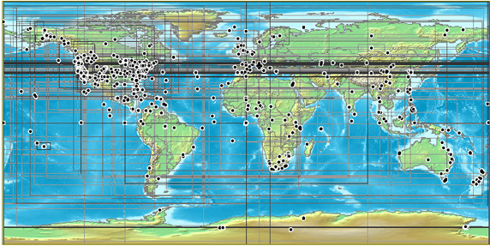
Figure 5.25: A map generated by Metacat's GeoServer. Points and "bounding boxes" represent the geographic extent of datasets stored in the KNB Metacat repository.

GeoServer supports a wide variety of vector GIS data sources, which can be styled using Styled Layer Descriptors (SLDs) and output as images (the default) or raw vector data (GML or KML).

Currently, GeoServer can be used with the following limitations:

- The GeoServer will only map documents that are publicly available. This is because the mapping server's support for permissions control is not as fine-grained as Metacat's.
- The GeoServer can only access documents the conform to one chosen schema. This is because only one set of xpaths can be defined in the Metacat properties.
- GeoServer 1.4, the version bundled with Metacat, does not support raster input (e.g., satellite imagery or digital elevation models). We suggest setting up UMN Mapserver if you aim to serve raster data.

Metacat developers plan to continue extending and improving Metacat's mapping capabilities. If you are interested in contributing to those efforts, or if you are interested in learning more about the architecture and future plans for the mapping software, please see http://knb.ecoinformatics.org/software/metacat/spatial_option.html.

Installing and Configuring

Metacat's GeoServer is automatically installed when Metacat is installed. If you do NOT wish to run the GeoServer, set the runSpatialOption property in the lib/metacat.properties file to false before building Metacat from source (?).

The GeoServer bundled with Metacat comes with a world-countries base layer and a default configuration that is already aware of Metacat's spatial cache. To further configure GeoServer, use its Web-based configuration utility, available at http://your.server/context/geoserver.jsp (Figure 5.2). Some configurations may need to be made to the XML files as well.

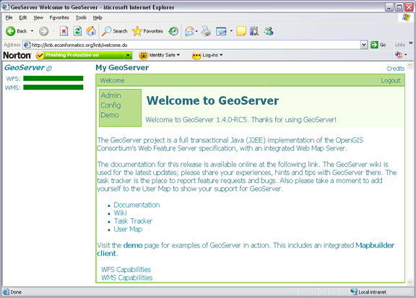
Figure 5.26: GeoServer's web-based administrative interface.

NOTE: By default, the first time Metacat is restarted, it generates a "spatial cache" containing geographic information about documents in its repository. This default behavior is specified in lib/metacat.properties, where the regenerateCacheOnRestart parameter is set to true. The information in the spatial cache is stored in a GIS-compatible format (the ESRI Shapefile) and consists of the document name and its geographic coverage. When documents are inserted, deleted, and updated in the Metacat repository, Metacat automatically syncs the spatial cache to reflect the changes. Because generating the cache can take a considerable amount of time--several minutes in the case of a few thousand documents--Metacat automatically resets the regenerateCacheOnRestart property to false after the spatial cache has been generated. Note that if you upgrade or reinstall Metacat, the spatial cache will be regenerated again.

CONFIG? It is important to note that, at the moment, only one set of xpaths are defined in metacat.properties meaning only documents of the chosen schema can be accessed by the spatial harvester.

CONFIG? Also note that, for performance reasons, the xpaths to the bounding coordinates must also appear in your indexPath (defined in build.properties).

Add a Map to a Web Page or Skin
To add a map to a Web page, simply include the map interface using an iframe:

<iframe scrolling="no" frameborder="0" width="736" height="520"
src="/knb/style/common/spatial_templates/spatial1/map.html">
</iframe>

The map URL, /knb/style/common/spatial_templates/spatial1/map.html, is the default map interface. If you plan to customize the map interface, copy the spatial1 directory into your skin's directory.

cp -r style/common/spatial_templates/spatial1/style/skins/myskin/spatial

If you do not have a customized skin, just copy the template into the default skin's directory?

You can access the customized map with the URL: /knb/style/skins/myskin/spatial/map.html

Configure the Size and Initial Extent of the Map

Before you configure the size and initial extent of the map, make sure that you have copied the default spatial settings into your skin's directory (See section 5.1.1 for directions). Once the settings have been copied, you can modify the map's initial extent in the context settings: ${skin.dir}/spatial/context.xml.

To change the map size and/or initial extent, edit the following lines:

<Window width="720" height="360" />
<BoundingBox SRS="EPSG:4326" minx="-180" miny="-90" maxx="180" maxy="90" />

Where width and height specify the map size in pixels, minx/maxx represent the range of longitudes and miny/maxy represent the range of latitudes.

Configure the Layout of the HTML Mapping Interface

Before you configure the size and initial extent of the map, make sure that you have copied the default spatial settings into your skin's directory (See section 5.1.1 for directions). Once the settings have been copied, you can modify the layout here: ${skin.dir}/spatial/map.html.

Map.html is a simple HTML file with a tabular layout. Map components are abstracted into "widgets", blocks with a specific id (e.g., locationsSelect and mainButtonBar), which can be reorganized within the table.

For deeper customization, modify the Web map context document (${skin.dir}/spatial/context.xml) and the mapbuilder configuration file (${skin.dir}/spatial/config.xml).

Change the Lat/Long Display to Degree-Minutes-Seconds

By default, the map display shows the cursor's position in decimal degrees (the preferred format for many GPS/GIS applications). To report coordinates as degrees minutes-seconds, edit the spatial configuration file:

- If you have not already copied the default spatial settings into your skin's directory, do so now (See section 5.1.1 for directions)
- Open the ${skin.dir}/spatial/config.xml file.
- Edit the CursorTrack widget:

<CursorTrack id="cursorTrack">
<mouseHandler>mainMap</mouseHandler>
<showDMS>true</showDMS>
<showLatLong>true</showLatLong>
</CursorTrack>

- Save and close the configuration file.

Configure the "Select Location" Drop-down Menu

Before you configure the menu items, make sure that you have copied the default spatial settings into your skin's directory (See section 5.1.1 for directions). The locations that appear in the "Select Location" drop-down menu are specified in the ${skin.dir}/spatial/named_locations.xml file. Each location is defined as a gml:featureMember. Edit the featureMember's gml:name and gml:coordinates fields to edit or add new locations.

<gml:featureMember>
<locationDef>
<gml:name>ACM Wilderness Field Station</gml:name>
<spatialKeyword>
<gml:location>
<gml:Envelope srsName="http://www.opengis.net/gml/srs/epsg.xml#4326">
<gml:coordinates>-91.956,47.87 -91.706,48.12</gml:coordinates>
</gml:Envelope>
</gml:location>
</spatialKeyword>
</locationDef>
</gml:featureMember>

Configure the Visual Portrayal of the Geospatial Data (e.g., symbology and color)

Geospatial data sets are styled through the use of Styled Layer Descriptors (SLD). The default SLDs used for the data points and data bounding boxes are in
/lib/spatial/geoserver/data/styles/ and are named data_points_style.sld and data_bounds_style.sld, respectively.

You can find a more detailed tutorial on using SLD with GeoServer at: http://docs.codehaus.org/display/GEOSDOC/SLD+Intro+Tutorial. BROKEN LINK/maybe I don't have correct permission??

Add Other Spatial Datasets to the Web Map
If you have vector GIS data sets, such as weather or topographical information, on your server that you'd like to include in the interactive map, you must first register the data set with GeoServer. After the data set has been registered, you can add the layer to the map. You can also add spatial layers that have been made publically available through WMS (There are hundreds of spatial data sets available. Check out wms-sites.com for good catalog). Instructions for adding publically available layers are included at the end of this section.

To register the data set and add it to the map:

- Point your browser to http://your.server/context/geoserver.jsp, log in to GeoServer, and navigate to the "Data Stores" configuration page under Config > Data > Stores.
- Create a new Shapefile and assign it a DataStore ID (Figure 5.3). The DataStore ID can contain letters and numbers. It is just used internally, and should be unique. Click New.

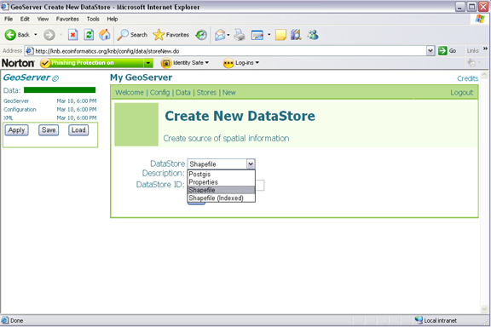
Figure 5.27: Creating a new shapefile using GeoServers web-based administrative interface.

- On the next screen, select the "metacat" namespace from the drop-down menu and point to the GIS data file on the file system (relative to {tomcat.dir}/webapps/{context}/). The Description, if specified, is mostly used internally to provide other administrators with information about the DataStore. Click Submit.

- Navigate to the "Feature Type" configuration page under Config > Data > Feature Type. Select your new data store from the drop-down menu. Click New.

- Style the layer using a style from the drop-down style menu, or click "Create new SLD" to create a new Style object and corresponding SLD (this option provides more control over the style). You should also define a spatial reference system (SRS) number for the new layer. Most lat/long data is "4326". If your data is in another projection, determine its spatial reference system using the help links provided (Figure 5.4).

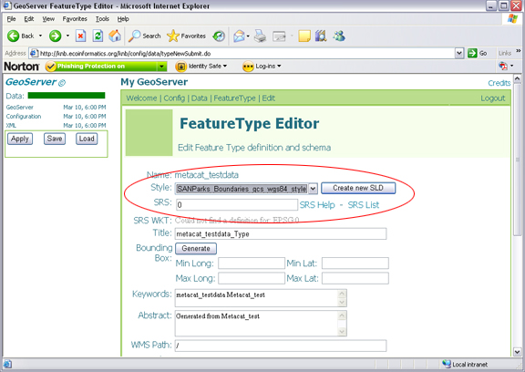
Figure 5.28: GeoServer's FeatureType Editor. The Style and SRS settings discussed in step 5 are highlighted.

- Click "Apply" and "Save"

- Try out the styled data set as a WMS layer using a URL like: ??
http://your.server/context/wms?VERSION=1.1.1&REQUEST=GetMap&SERVICE=WMS&LAYERS=metacat:newLayer&SRS=EPSG:4326&BBOX=-180,-90,180,90&WIDTH=720&HEIGHT=360&FORMAT=image/gif&STYLES=&TRANSPARENT=TRUE&UNIQUEID=

If data is properly displayed, add the map to your map context document (step 7).

- Locate the Web map context document (usually {skin}/spatial/context.xml) and open the file in a text editor.

- Locate the Layer entry for an existing layer next to which you want to stack your layer (the first layers in the context are rendered at the bottom).

- Create a new Layer entry, by copying and pasting the existing entry for the metacat data_points layer and editing the Layer Name and Title. The title is displayed in the map legend. Note: if you'd like to use transparency, leave the image format set to image/gif (IE pre-7 has trouble with PNG transparency).

<Layer queryable="0" hidden="0">
<Server service="OGC:WMS" version="1.1.1"
title="DatasetPoints">
<OnlineResource xlink:type="simple" xlink:href="../../../../wms" />
</Server>
<Name>metacat:data_points</Name>
<Title>Dataset Points</Title>
<SRS>EPSG:4326</SRS>
<FormatList>
<Format current="1">image/gif</Format>
</FormatList>
</Layer>

- Point your browser to the map interface. Your new layer should appear with the existing ones.

Adding External Spatial Data Made Publically Available through WMS

There are hundreds of sources of spatial data made publically available through WMS. (check out wms-sites.com for good catalog). To add these data sources to your map, locate your skin's context file (${skin.dir}/spatial/context.xml) and add a new Layer by copying and pasting an existing Layer and modifying as appropriate: modify the OnlineResourceURL, Name, Title and Style to match the WMS layer you'd like to use. See the mapbuilder Add WMS Tutorial for further details.

Spatial Query
Displaying the spatial cache as a map is important but users also need to query the spatial cache in order to answer the question "What documents lie in this geographic region?". The functionality is invoked through the metacat servlet itself; there is a spatial_query action for this purpose. An example spatial query would be:
http://localhost/knb/metacat?action=spatial_query&xmin=-117.5&xmax=-64&ymin=3&ymax=46&skin=default
Where xmin, xmax, ymin and ymax represent the west, east, south and northern bounding coordinates respectively. This will return an html document listing (in the style of the specified skin) all documents whose geographic coverage intersect the given bounding box.
The core functionality of the spatial query mechanism is found in the edu.ucsb.nceas.metacat.spatial.SpatialQuery class and, like the spatial harvester, relies heavily on the Geotools library. This class has a single method, filterByBbox(), which compares the bounding box to both the point and polygon cache. For each shapefile, the process requires two steps: First, filter the spatial cache for features whose bounding box overlaps the specified bounding coordinates; Second, iterate through the remaining features to find those that are fully contained by the bounding box. The second step, though more costly than comparing the bbox, is necessary because the feature's geometry may be a multi-geometry whose bounding box is large but whose component primitive geometries are scattered over that area. The end result is a vector of docids matching the spatial query.
This docid list is then sent to DBQuery. Using a special constructor that takes a vector of docids, the DBQuery class is able to use the Docid override mechanism to perform an optimized query (for cases where the list of docids is already known).

HTML Mapping Client
In order to provide a web-based user interface to the WMS and the spatial query functionality, Metacat relies on Community Mapbuilder. Mapbuilder is a pure HTML/javascript application which uses AJAX and XSLT on the client side to create a desktop-GIS-like environment for interacting with geographic data through a web browser.
The main function of mabuilder is to act as a front-end to WMS services. The WMS layers are configured through a Web Map Context document (typically found in the skin directory under spatial/context.xml). This context document (or WMC) can define the initial extent of the map, the ordering and visibility of layers and, of course, the source and name of the WMS layer.
Mapbuilder provides several interface components or widgets (map, box zooms, layer list, "select location" dropdown, scalebar, coordinates, info query) that make it easy to deploy highly-functional web mapping applications with minimal coding. There are three main configuration files you need to work with in order to customize the map interface: The context document discussed above, the mapbuilder configuration file (typically under spatial/config.xml) which defined the widgets and their behavior and finally the html file (typically spatial/map.html) which loads the mapbuilder javascript library and places the widgets in your html layout.
For integration with metacat, we built a custom mapbuilder widget, the AOIMetacat Query, which allows you to click query the map, either by box or point, and call the metacat spatial_query action.
The cleanest way to integrate a mapbuilder interactive map with any page in your application is to simply create an iframe element with the src pointing to a standalone map.html.

Replication

Harvester and Harvest List Editor

Logging

Creating a Site Map

Appendix: API (maybe here)

NOT SURE WHERE LDAP SERVER SHOULD GO

--
Have no idea why need a sax parser and what it does/how/when used (Saxparser.html)

--
LDAP: Not sure if this needs install/etc.

